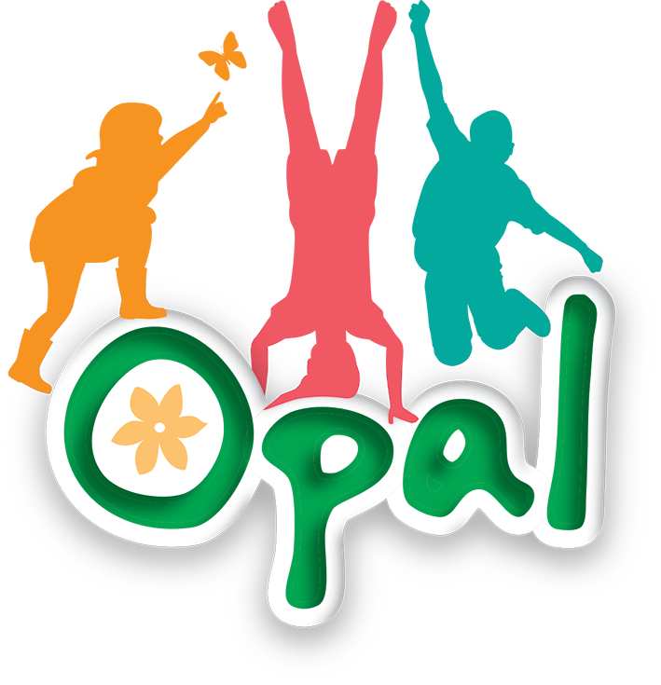

Risk Benefit Assessment
Scooters/ Wheels

Benefits:
1. Physical Activity – Encourages exercise, improving cardiovascular health, coordination, and balance.
2. Motor Skills Development – Enhances fine and gross motor skills, aiding in overall physical development.
3. Independence & Confidence – Helps children develop a sense of freedom, control, and self-confidence.
4. Social Interaction – Promotes play with peers, teamwork, and outdoor engagement.
5. Fun & Recreation – Provides enjoyment, reducing screen time and encouraging outdoor activities.
Activity ideas:
Obstacle Courses
Set up cones or chalk lines for kids to weave through, following one way system. Time them to see who can complete the course the fastest.
Risks:  Falls & Injuries – Common risks include scrapes, bruises, and more serious fractures or head injuries.  Poor Posture & Overuse Injuries – Prolonged use can cause muscle strain if not used properly.  Weather Conditions – Slippery or uneven surfaces increase the risk of falls.  Supervision Issues – Younger children may struggle with control, leading to unexpected accidents.  Impalement – Risk of child being impaled if hand grips are not on the handlebars. | Risk Management:  - Playworkers check scooters daily for wear/tear/breakages.  - Weekly full inspection completed by site supervisor  - Teach the children safety rules and supervise their riding.  - Use safe area- the specific area of the playground.  - Ensure the scooter is age-appropriate and in good condition.  - Ensure all scooters have hand grips to reduce risk of impalement.  - If there is wet weather and playground surface becomes slippery and/or the scooters become slippery then Playworker supervising area to make decision to put away and close area
Additional information to be considered:

Message to parents:
As part of our OPAL Play provision, we are introducing a new Scooter Zone on the playground at lunchtimes. After completing a thorough Risk-Benefit Assessment, we have decided that pupils will not be required to wear helmets while using scooters.
This decision is based on safety guidance which highlights that ill-fitting helmets (such as those with loose chin straps) can pose risks equal to or greater than not wearing a helmet. Additionally, helmets can create entrapment hazards when children are not on their scooters. The speed at which children will be riding on our school site is very low, and there is no traffic or vehicles present, making helmets unnecessary in this context.
Supervision and Safety Rules
- The Scooter Zone will be fully supervised by staff at all times.
- Pupils must ride sensibly and at a safe speed.
- Scooters must only be used within the designated zone. There will be a one-way system in place.
- No tricks, jumps, or racing are allowed.
- Pupils must take turns and show respect for others using the space.
We are excited to offer this new play opportunity and will continue to monitor safety closely.

