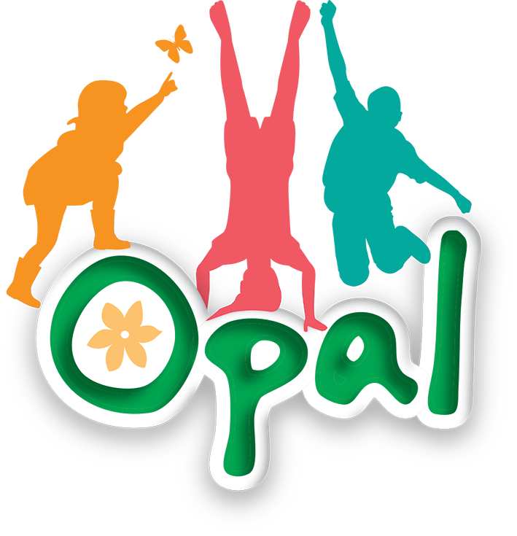

Risk Benefit Assessment
Sports equipment

Benefits:
- Physical Development
- Improves coordination, balance, agility, and cardiovascular fitness
- Develops fine and gross motor skills
- Social Development
- Encourages cooperation, turn-taking, and teamwork
- Builds communication skills and friendships
- Emotional Wellbeing
- Provides stress relief and enhances mood
- Builds resilience through trial and error
- Cognitive Development
- Promotes problem-solving (e.g. inventing games)
- Encourages creativity and imagination
- Inclusion
- Offers varied entry points for all pupils regardless of ability
- Supports independent and child-led play choices
Activity ideas:
Children may engage in:
- Skipping (individual, partner, group games)
- Catching and throwing games (balls, beanbags)
- Target games (aiming beanbags or balls into hoops)
- Balancing activities (hoops, beanbags on heads)
- Throw-and-catch (cup and ball)
- Cooperative games (passing balls, relay-style activities)
- Frisbee throwing and catching
- Invented games created by pupils
Risks:  Skipping ropes (rope & plastic)  Tripping, entanglement, accidental striking  Ankle skips  Trips, falls, misuse (e.g. throwing)  Cup and ball  Striking self/others, frustration leading to unsafe behaviour  Tennis balls / small balls  Being hit, slipping on loose balls, throwing at others  Frisbees  Impact to face/head, misuse as objects to throw forcefully  Hoops  Tripping, misuse (rolling into others)  Beanbags  Throwing at faces, slipping risk if dropped | Risk Management:  General Supervision  - Active adult presence during lunchtime  - Adults trained in OPAL principles to allow managed risk rather than eliminate challenge  Clear Expectations  - Teach and reinforce safe use of equipment  - “Use equipment for its intended purpose”  - No throwing directly at people unless part of a structured game  Zoning the Playground  - Designate areas for different types of play (e.g. throwing zone, quiet play zone)  - Reduce congestion and collisions  Equipment Management  - Regular safety checks for damage (frayed ropes, broken items)  - Limit quantity to manageable levels to reduce clutter  Behaviour Management  - Clear consequences for unsafe use  - Encourage restorative conversations when issues arise  Progressive Skill Building  - Teach safe techniques (e.g. how to throw/catch, skip safely)  - Model appropriate use  Environmental Considerations  - Remove excess loose equipment that may create trip hazards
Additional information to be considered:
Inclusivity: Ensure a range of equipment meets diverse needs (physical, social, sensory)
Pupil Voice: Gather feedback from children about preferred equipment and emerging risks
Storage Systems: Safe distribution and collection of equipment
Special Educational Needs: Additional support or adapted equipment where needed
Staff Training: Ongoing OPAL training to support risk-benefit thinking

Message to parents:
To support transparency and understanding:
The school follows an OPAL approach, which values risk as an essential part of healthy development
Children are encouraged to engage in active, child-led play with appropriate levels of challenge
Minor bumps and scrapes may occur as part of normal play and learning
Equipment is carefully supervised and risk-managed, not risk-free
Parents can support by ensuring:
Appropriate footwear for active play
Understanding of the benefits of outdoor play

