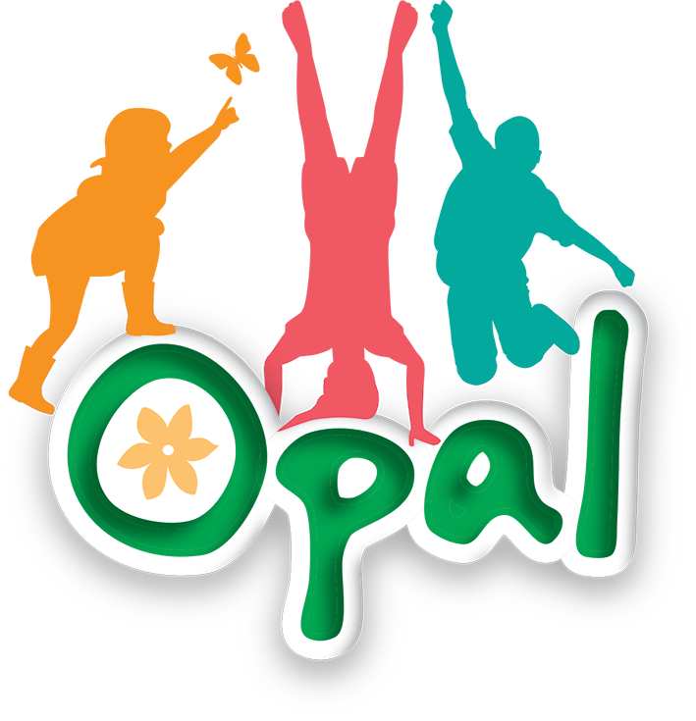

Risk Benefit Assessment
Small World

Benefits:
- Imagination and creativity
- Children create narratives and scenarios, developing storytelling and symbolic thinking skills.
- Social development
- Encourages cooperation, turn-taking, role-play, and negotiation between peers.
- Emotional expression
- Allows children to process real-life experiences through play (e.g., doctor kits for role-play).
- Language development
- Promotes conversation, vocabulary expansion, and storytelling.
- Fine motor skills
- Handling small objects improves coordination and dexterity.
- Engagement and inclusion
- Provides a calmer alternative to physically active play, benefiting children who prefer quieter activities.
- Wellbeing and regulation
- Supports relaxation and emotional regulation during unstructured time.

Activity ideas:
Children may engage in:
- Create imaginative worlds using dinosaurs, dolls, or action figures
- Build structures (e.g., towns, roads, landscapes) with blocks
- Use ramps to experiment with speed, distance, and simple physics
- Engage in role-play (e.g., families, superheroes, doctors/patients)
- Collaborate to create shared storylines or scenarios
- Sort, group, or organise objects as part of play
Risks:  Small figures (dinosaurs, dolls, action figures)  Choking hazard (younger children), throwing objects  Cars and trucks  Collisions, minor injuries from throwing or misuse  Small ramps  Trip hazards if left on ground, misuse (e.g., stepping or jumping on them)  Building blocks  Trip hazards, falling structures, throwing  Doctor sets  Misuse (e.g., poking with tools), hygiene concerns if shared frequently  Mixed equipment  Clutter leading to trips/falls, disagreements between children | Risk Management:  Supervision  - Active staff presence to observe, support, and guide safe play  - Staff trained in OPAL approach—balancing risk with benefit  Clear Expectations  - Shared rules agreed with children (e.g., no throwing equipment, use items safely)  - Reinforce respectful and cooperative play  Environment Setup  - Defined area for small world play to reduce overlap with active play zones  - Equipment spread out to avoid overcrowding  - Regular checks to remove broken or damaged items  Equipment Management  - Age-appropriate resources selected  - Rotate equipment to maintain interest and reduce clutter  - Ensure no items are small enough to pose choking risks for younger pupils  Hygiene  - Regular cleaning of shared resources (especially doctor kits)  - Encourage handwashing before/after play  Behaviour Support  - Adults model positive interactions and conflict resolution  - Support children in sharing and negotiating during play
Additional information to be considered:
Inclusion: Ensure a wide variety of resources to reflect diversity and different interests
Accessibility: Provide resources that are usable by all pupils, including those with additional needs
Weather considerations: Ensure equipment is suitable for outdoor use; remove or adapt during wet conditions to prevent slipping
Storage: Safe storage solutions to prevent clutter and damage
Regular review: Monitor use of the area and adjust based on observations and pupil voice

Message to parents:
The school values play as an essential part of development and follows OPAL principles
Children will engage in creative and imaginative play using varied equipment
There is a balanced approach to risk, helping children learn independence, cooperation, and problem-solving
All reasonable steps are taken to ensure safety through supervision and risk management
Minor bumps or disagreements are a normal part of learning through play
Parents are encouraged to support play opportunities at home

