

Doxey Academy Music Development Plan

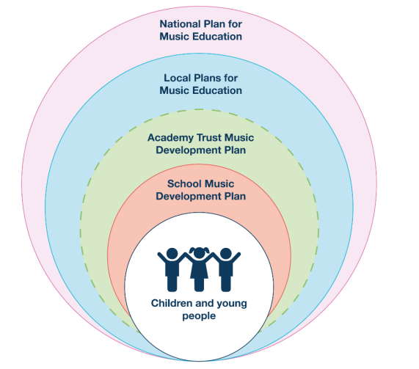

Music development plan summary:
Doxey Academy
At Doxey Academy we are committed to deliver a high-quality music curriculum, co-curricular music and musical experiences. School music provision takes account of the key features in the national plan for music education:
- timetabled curriculum music of at least one hour every 2 weeks of the school year for key stages 1 to 2
- access to lessons across a range of instruments
- a school choir or vocal ensemble
- space for rehearsals and individual practice
- a termly school performance
- opportunity to enjoy a live performance at least once during their time at school

This document should be read in conjunction with the Trust’s education strategy and conception of quality for music.

The Trust’s music mission is as follows:
Music is an essential part of the curriculum and our lives. It has special powers. A great education in music is a right for every child. We take this right seriously and work to ensure that children receive a rich and inspiring high-quality music curriculum. We know that a strong musical curriculum is also built on partnerships - we work closely with music teachers and organisations to develop a broad menu of experiences and opportunities.

Overview
Detail | Information
Academic year that this summary covers | 2025-2026
Date this summary was published | September 25
Date this summary will be reviewed | September 26
Name of the School music lead | Allyson Sinclair
Name of local music hub | Entrust Support Services  (Covering Shropshire, Staffordshire, Stoke on Trent, Telford & Wrekin)

Part A: How the Trust supports Doxey Academy to consider what makes for high quality teaching.
This is about what we teach in lesson time and how much time is spent teaching music.
Doxey Academy are part of the music network which meets termly to consider the quality of music teaching across the trust.
Our thinking is informed by our educational philosophy and strategy. In all our curriculum thinking we draw a careful distinction between curriculum, pedagogy and assessment – this ensures that the core knowledge we want pupils to know and remember in music is at the forefront of our thinking.
We are a research/evidence informed organisation. That means that we draw upon ‘best bets’ from the education sector to build our curriculum offer. We have invested much time in recent years in setting out our ‘conception of quality’ – our shared idea of what makes for quality practice. This helps us all improve together and have a shared foundation of knowledge and thinking to build upon. This strong ‘conception of quality’ drives our school improvement work and collaboration. We have rationalised and summarised complex school improvement thinking into accessible documents that help us focus on the most important things.

What this thinking looks like at Doxey Academy
Every student receives one hour of music every two weeks in KS1 and KS2. We follow the Charanga scheme, which ensures that students are offered opportunities to sing and play an instrument during their lesson time as well as learning about musical appreciation, understanding how the elements, notation etc are used to produce a piece of music. We work closely with our local music hub, other music leads from our trust and also with other schools across Staffordshire – sharing ideas and good practice. Music is always a very accessible subject for SEND pupils and our curriculum offers plentiful opportunities for SEND pupils to be included.

Part B: What this thinking looks like…
Our main aim is to ensure pupils make more music, think more musically and become more musical.
Our conception of quality is an evolving document. It sets out our high-level principles relating to curriculum, pedagogy and assessment. The PDF snips on pages 5 and 6 exemplify our network thinking – the words and aims outlined below will be continually updated.
The ideas and expectations below were written by our leaders of music for our schools.

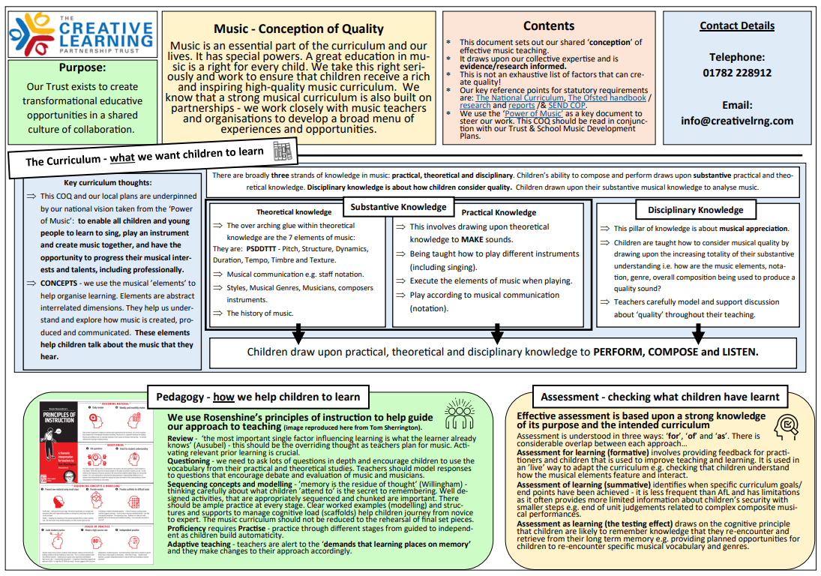
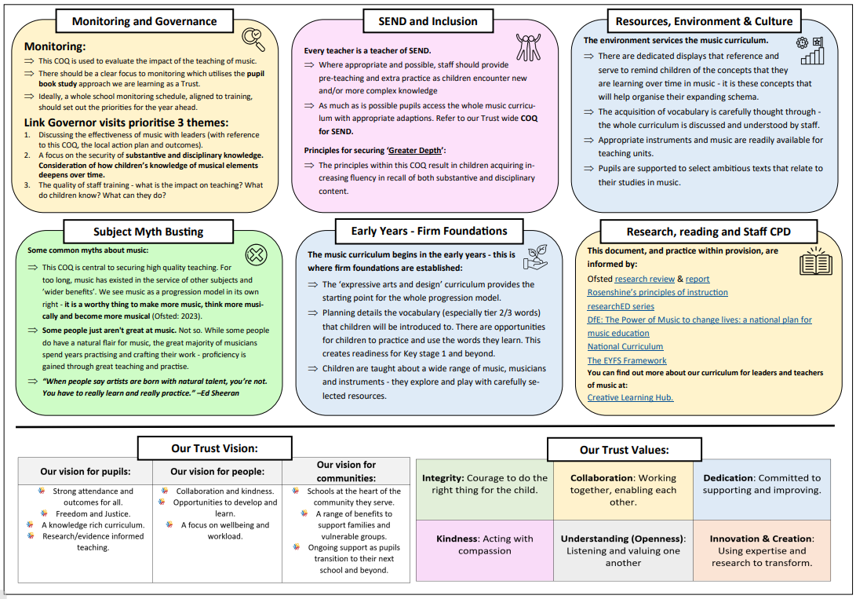

Part C: Extra- curricular music
This is about opportunities for pupils to sing and play music, outside of lesson time, including choirs, ensembles and bands, and how pupils can make progress in music beyond the core curriculum.
Our school offers peripatetic music lessons during school time run by Entrust, offering students the opportunity to learn guitar or keyboard in years 4-6. These can be individual or group lessons.
Every year Doxey Academy takes part in Young Voices, which has been very popular. We have taken around 50 pupils from years 5-6. These year groups practice daily. Our school choir features strongly at Young Voices as well. This choir rehearses weekly after school and performs at school open days, school fetes, Christmas fayres and in school assemblies. This gives the children the opportunity to perform in front of their peers, parents and carers.

Part D: Musical Experiences
This is about all the other musical events and opportunities that we organise, such as singing in assembly, concerts and shows, and trips to professional concerts.
As part of our mission to develop the children’s cultural capital, the children listen to a genre of music every week in assembly. This gives them an insight into a variety of different styles of music that they may not otherwise be exposed to.
At Christmas Nursery, Reception and Key Stage 1 perform a Christmas play for the rest of the school and parents and carers. All children have the opportunity to act, dance and sing, developing their confidence to perform.
At the end of the Summer term, year 6 perform a leavers assembly to the school and parents and carers. This is another opportunity for the children of Doxey to showcase their talents and enthusiasm for Music.
This academic year the children at Doxey will have another opportunity to perform at the Young Voices. This experience will allow them to see other professional performers during the rehearsal and concert and perform in front of a large crowd. The school choir will also be taking part in Stafford’s Gotta Sing concert at the Gatehouse Theatre.

Part E: In the Future
This is about what the school is planning for subsequent years.
The first plan on the agenda is to deliver the Charanga scheme to all of KS1 and KS2 using the instruments recently purchased, alongside using the Music concept of quality with the other schools from the trust. The impact of the scheme will then be monitored and future actions put in place.
As part of the vision at Doxey Academy, we want to increase the cultural capital by organising trips for the children to attend concerts in a variety of venues.
We would like to encourage the choir and musicians to take part in a termly performance, displaying what they have learnt over the term. This will give the children a purpose for learning to play a particular instrument and confidence to perform.

