
Personal Development Curriculum
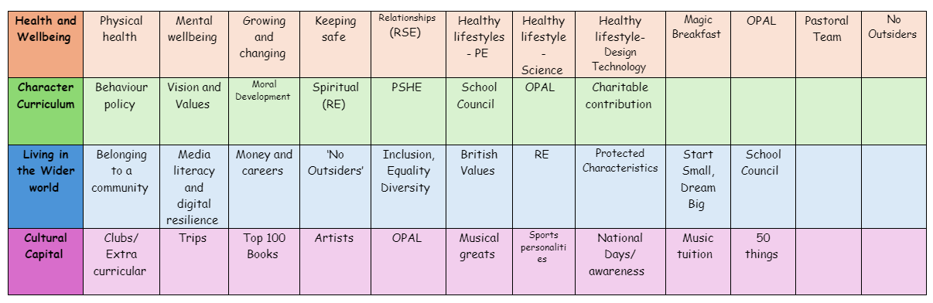
British Values
Teaching British values in schools is important for several reasons. These values—democracy, the rule of law, individual liberty, mutual respect, and tolerance of those with different faiths and beliefs—form the foundation of a democratic society and help students develop a sense of responsibility, respect, and citizenship.
1. Promotes Social Cohesion
Teaching British values helps students understand the principles that bind society together, creating a sense of shared identity and belonging. By focusing on values such as mutual respect, tolerance, and individual liberty, schools foster an environment where all students feel valued, regardless of their background, culture, or beliefs. This contributes to social harmony and reduces the potential for division or conflict.
2. Encourages Respect for Diversity
British society is increasingly diverse, with people from a variety of cultures, religions, and backgrounds. Teaching values like tolerance and respect helps students appreciate and understand differences. It promotes positive attitudes towards diversity and helps combat discrimination, prejudice, and intolerance, fostering a more inclusive society.
3. Prepares Students for Citizenship
British values are closely linked to the rights and responsibilities of citizens in a democratic society. Teaching these values helps students understand how democracy works, the importance of voting, the rule of law, and how to be responsible and active citizens. Students learn how to engage with and contribute to their communities, making them more likely to participate in democratic processes and social issues in the future.
4. Supports the Development of Moral and Ethical Understanding
By teaching British values, schools provide a framework for students to reflect on moral and ethical issues. Students are encouraged to think about fairness, justice, and their responsibilities to others. These values guide their decision-making and behaviour, promoting a society where people care for one another and act with integrity.

5. Fosters Critical Thinking and Civic Responsibility
British values, particularly democracy, encourage critical thinking. Students are taught to question, debate, and understand different viewpoints, which is essential for making informed decisions. They also learn about the importance of the rule of law and individual liberty, enabling them to navigate complex societal issues with respect and responsibility.
6. Helps Counter Extremism
Teaching British values is a key way to challenge extremist ideologies and harmful behaviours. By instilling values such as tolerance, respect for others, and democracy, schools help students understand the importance of peaceful coexistence and non-violence. These values act as a safeguard against radicalization, encouraging young people to resist extremist views and to understand the consequences of intolerance and hate.
7. Builds a Sense of Identity and Belonging
Understanding British values helps students feel more connected to their country and culture. It provides a framework for them to better understand what it means to be a member of society, creating a shared understanding of rights, duties, and values. This sense of belonging contributes to students’ emotional well-being and sense of security.
8. Encourages Respect for the Rule of Law
The rule of law is a cornerstone of British society, ensuring that everyone is treated fairly and equally under the law. By teaching students about the rule of law, schools help them understand the importance of abiding by laws, respecting authority, and resolving conflicts peacefully. This fosters a sense of justice and accountability, which is essential for a stable and functioning society.
9. Promotes Personal Development and Well-being
British values promote individual liberty, which encourages students to make choices and take responsibility for their actions. Students learn about the importance of respecting the rights of others while also exercising their own freedoms. This supports personal development and well-being, helping students grow into confident, self-aware individuals who can navigate the world responsibly.
10. Supports Equality and Social Justice
By teaching British values, schools highlight the importance of equality and fairness in society. Students learn about the rights of all individuals, regardless of their background, gender, or identity. British values promote equality of opportunity, helping students understand the importance of ensuring that everyone has the chance to succeed, regardless of their starting point in life.
11. Aligns with National and International Values
While British values are rooted in the UK’s democratic traditions, they align with broader global values such as human rights, democracy, and social justice. Teaching these values helps students understand their place in a globalized world and how British society fits into the broader international context. It encourages them to be responsible global citizens who contribute positively to their communities and the world.

12. Fosters Positive Relationships
Values such as mutual respect and tolerance encourage positive relationships between students, staff, and the wider community. Students are encouraged to treat others as they would like to be treated, promoting kindness, understanding, and cooperation. This helps to create a positive school culture and ensures that everyone feels safe and valued.
How we promote British Values
- Monthly assemblies which focus on each British Value in turn
- Democracy- Class elections for school council
- Democracy- Pupils debate different issues in a structured manner, where they can express their opinions and listen to others
- Democracy- Pupils are involved in decision-making about class rules
- Rule of Law- Set and maintain clear school rules that are fair and consistent. Discuss why rules are important and how they help ensure fairness and safety for everyone. Reinforce the idea that rules apply to everyone equally.
- Individual liberty- Create a classroom environment where students are encouraged to express their thoughts, ideas, and opinions freely.
- Mutual respect- staff demonstrate respectful behaviour in all interactions with pupils, colleagues, and parents
- Tolerance of Those with Different Faiths and Beliefs- we incorporate lessons, activities, and celebrations related to the different cultures, religions, and traditions represented in our class and community. This involves exploring world religions and learning about different cultural festivals.
- Tolerance of Those with Different Faiths and Beliefs- teach about leaders who championed tolerance and equality, such as Martin Luther King Jr., Mahatma Gandhi, or Nelson Mandela. Discuss their lives and the impact of their work on promoting mutual respect and understanding.
- We use PSHE lessons to explore British values, discussing topics such as how to respect others’ rights, understanding cultural diversity, and the importance of participating in democracy.

