
Personal Development Curriculum
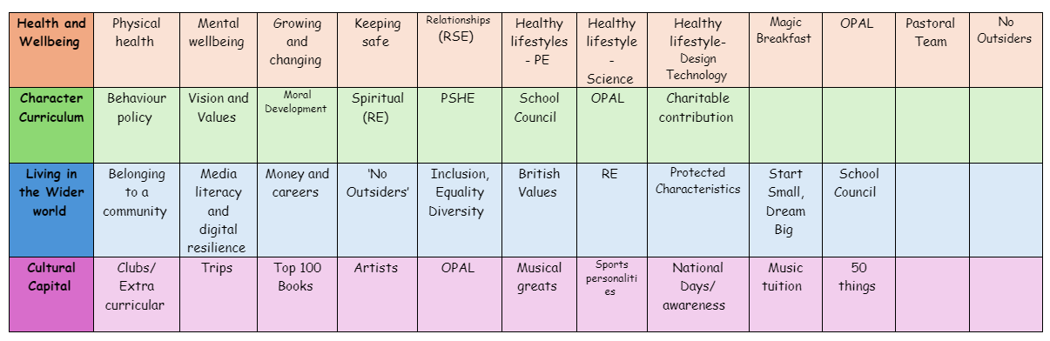
Inclusion, Equality and Diversity
Teaching pupils about inclusion, diversity, and equality is crucial for fostering a positive, respectful, and harmonious society. These concepts not only help shape the character of students but also prepare them for the diverse and interconnected world they will navigate as adults.
1. Promoting Respect for All Individuals
Teaching about inclusion, diversity, and equality helps children understand the value of respecting people from different backgrounds, cultures, and experiences. By learning to appreciate differences, students are less likely to engage in prejudice or discrimination. They develop the ability to treat everyone with dignity and respect, regardless of their race, gender, ability, religion, or socioeconomic status.
2. Fostering Empathy and Compassion
When students learn about the challenges that others face—whether related to race, gender, disability, or socioeconomic status—they develop empathy and a deeper understanding of others' emotions and struggles. This emotional connection encourages compassion and the desire to support and help people who may be different from themselves.
3. Breaking Down Stereotypes and Biases
Education about diversity helps break down harmful stereotypes and misconceptions. When children are exposed to diverse perspectives, they begin to challenge preconceived notions and biases. This encourages open-mindedness and helps prevent the spread of discrimination in the future.
4. Building an Inclusive Community
Teaching inclusion ensures that all students feel accepted and valued within their school community. It helps create an environment where everyone, regardless of their background or abilities, feels they belong. This sense of belonging is essential for students’ emotional well-being and overall academic success.

5. Encouraging Equality of Opportunity
Understanding equality helps students recognise that everyone deserves the same opportunities and rights, regardless of their background or circumstances. It teaches the importance of fairness and justice, encouraging students to stand up for equality and advocate for the rights of others, especially those who may be marginalised or disadvantaged.
6. Preparing for a Global Society
The world is becoming increasingly interconnected and diverse. By learning about inclusion and diversity, students are better equipped to live and work in a global society. They gain the skills necessary to communicate, collaborate, and problem-solve with people from different cultures and backgrounds. This prepares them for a future where cultural competence and adaptability are key assets.
7. Encouraging Social Cohesion
Schools that emphasise inclusion and equality help promote social cohesion. Students learn to appreciate the value of living in a society where differences are celebrated rather than feared. This mindset helps reduce social tensions and fosters peaceful relationships among people from various walks of life.
8. Instilling a Sense of Social Responsibility
Teaching these values encourages students to become active, responsible citizens who are committed to creating a fairer, more just society. Students learn that they have a role to play in standing up against injustice, promoting equality, and supporting their peers, particularly those who may be marginalized or underrepresented.
9. Improving Academic Outcomes
When students feel included and valued, they are more likely to thrive academically. Inclusion promotes an environment where all learners feel supported, and diverse teaching methods can be applied to meet the needs of all students. This can result in better engagement, participation, and academic achievement for everyone, regardless of their background or ability.
10. Supporting Mental and Emotional Well-Being
Inclusion and diversity education helps students understand their own identities and the identities of others, which supports their mental and emotional health. When children feel that their unique qualities are accepted and celebrated, they develop higher self-esteem and a more positive sense of self. This can reduce feelings of isolation or marginalization, leading to better emotional well-being.
11. Reducing Bullying and Discrimination
Teaching children about inclusion, diversity, and equality can significantly reduce incidents of bullying, racism, sexism, and other forms of discrimination. When children are educated about the harm that prejudiced behaviour causes, they are more likely to stand up for one another and prevent bullying from occurring in the first place.

12. Instilling Values of Justice and Fairness
By learning about equality and justice, students develop a strong sense of what is right and wrong. They understand the importance of fighting for fairness and advocating for change when they see inequality or injustice. This empowers them to become leaders and change-makers who can make a positive impact on society.
13. Creating a More Positive Future
Teaching inclusion, diversity, and equality equips students with the values and skills they need to contribute to a better, more inclusive society. By fostering a generation of young people who understand and value these principles, we are helping to create a future where discrimination, inequality, and exclusion are diminished, and where everyone has the opportunity to succeed and thrive.
How we promote Inclusion, Equality and Diversity
- Staff model inclusive behaviour.
- Monthly assemblies which focus on teaching about inclusion, equality and diversity
- Use teaching materials that reflect diverse perspectives, cultures, and experiences.
- Encourage open conversations about diversity, inclusion, and equality in the classroom.
- Celebrate different cultural holidays and events throughout the year either in whole school assemblies or in the classroom
- Actively address biased language, jokes, or behaviours when they arise. Use these moments as teaching opportunities to discuss why such comments or actions are hurtful and how they undermine inclusivity.
- Share stories of influential figures from diverse backgrounds who have made positive impacts on society.

