
Personal Development Curriculum
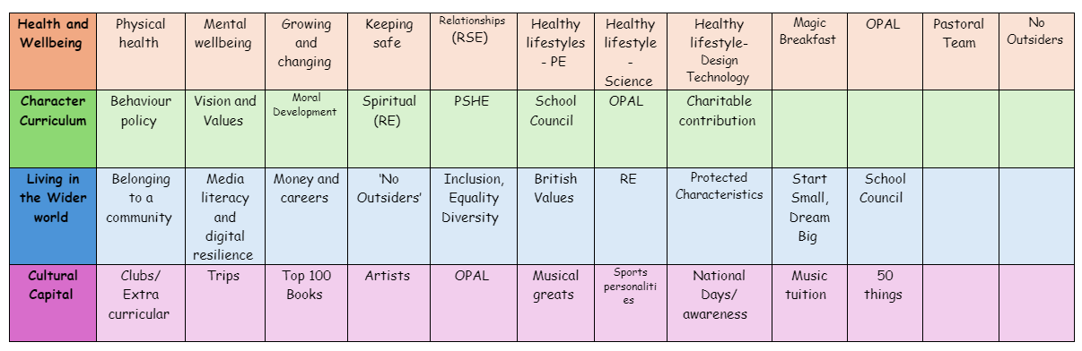
Money and Careers
Teaching children about money and careers is important because it lays the foundation for healthy financial habits, responsible decision-making, and a deeper understanding of the world of work. Early exposure to these concepts can help children develop essential life skills that will serve them well in the future.
1. Building Financial Literacy Early
Money is a crucial part of daily life, and understanding how it works is essential for success as an adult. Teaching children basic money concepts—such as saving, budgeting, and the difference between needs and wants—helps them make smart decisions with money as they grow. This early financial literacy can prevent poor financial habits later in life, such as excessive debt or poor spending choices.
2. Instilling the Value of Saving and Budgeting
Teaching children to save money and create simple budgets encourages responsible financial habits. When children understand that money must be managed wisely, they are more likely to grow up with a sense of discipline around spending, saving, and planning for future needs or goals (like buying a toy or saving for a trip). This habit of saving and budgeting is fundamental to long-term financial stability.
3. Encouraging Responsibility and Self-Sufficiency
Learning about money at a young age helps children develop a sense of responsibility and independence. By understanding that they need to work or save to earn money, children grasp the value of hard work and how their actions can directly affect their financial situation. This sense of personal responsibility is key to becoming self-sufficient and capable of managing their finances in adulthood.
4. Raising Awareness of Career Options
Introducing children to different careers and professions broadens their horizons and helps them realise the variety of paths they can pursue. It can spark curiosity about different industries, job roles, and the skills required for each. Early exposure to career possibilities can help children understand that there are many options available and encourage them to think about what interests them, ultimately leading to more informed decisions about their futures.

5. Promoting Goal-Setting and Motivation
Understanding money and careers also teaches children how to set goals. Whether it’s saving up for a specific item, managing a small allowance, or learning how different careers require specific skills and education, children learn the importance of working towards goals. This encourages a mindset of persistence and motivation, as they see that effort and planning are necessary to achieve success, whether financially or professionally.
6. Teaching the Link Between Education and Career Success
Explaining how education plays a role in career development helps children understand that learning and working hard in school can directly affect their future opportunities. This encourages children to take their studies seriously and recognise the value of gaining skills that will benefit them later in life, whether in a specific career or in managing their finances effectively.
7. Developing Critical Life Skills
Money management and career planning are life skills that will affect every aspect of a child's adult life. Understanding how to prioritise needs over wants, how to balance spending with saving, and how to make informed career choices helps children develop decision-making, planning, and critical thinking skills. These are essential skills they will continue to use throughout their lives in both personal and professional contexts.
8. Reducing Financial Stress in the Future
Early education about money can help children develop a healthier, more positive relationship with finances as they grow older. They are less likely to experience anxiety or stress about money because they have been taught how to manage it effectively from a young age. Financial literacy can prevent financial mistakes or crises later in life, reducing the burden of money-related stress.
9. Promoting Inclusivity and Economic Equality
Teaching children about money and careers can help bridge socioeconomic gaps by providing all children—regardless of their background—with the same fundamental knowledge. By introducing the idea that money management and career success are skills that can be learned, children from diverse economic backgrounds gain the tools to improve their financial futures and make informed decisions about their careers, regardless of where they start.
10. Helping Children Learn the Importance of Work-Life Balance
Learning about careers can also teach children the importance of work-life balance. They begin to understand that different careers offer different levels of flexibility, pay, and lifestyle. This helps them realise that choosing a career is not just about making money, but also about aligning their work with their interests, values, and personal well-being.
11. Inspiring Entrepreneurial Thinking
Exposure to money and career concepts may inspire children to think creatively about ways to earn money, including entrepreneurship. They may come up with ideas for small businesses or services that could help them understand the fundamentals of running a business. Early lessons in entrepreneurship can instil a sense of innovation, creativity, and initiative, which can be valuable in their personal and professional lives.
12. Preparing for Real-World Challenges
As children grow older, they will encounter challenges in managing their money and navigating career decisions. The more they learn about money and careers at an early age, the more equipped they will be to face these challenges with confidence and understanding. This proactive approach to education ensures that children are prepared to manage both their finances and their career choices wisely as they enter adulthood.
The following is the progression document in place to teach money and careers in dedicated PSHE lessons.
Year 1

- that everyone has different strengths, in and out of school
- about how different strengths and interests are needed to do different jobs
- about people whose job it is to help us in the community
- about different jobs and the work people do

Year 2

- about what money is and its different forms e.g. coins, notes, and ways of paying for things e.g. debit cards, electronic payments
- how money can be kept and looked after
- about getting, keeping and spending money
- that people are paid money for the job they do
- how to recognise the difference between needs and wants
- how people make choices about spending money, including thinking about needs and wants

Year 3

- about jobs that people may have from different sectors e.g. teachers, business people, charity work
- that people can have more than one job at once or over their lifetime
- about common misconceptions and gender stereotypes related to work
- to challenge stereotypes through examples of role models in different fields of work e.g. women in STEM
- about some of the skills needed to do a job, such as teamwork and decision-making
- to recognise their interests, skills and achievements and how these might link to future jobs
- how to set goals that they would like to achieve this year e.g. learn a new hobby

Year 4

- how people make different spending decisions based on their budget, values and needs
- how to keep track of money and why it is important to know how much is being spent
- about different ways to pay for things such as cash, cards, e-payment and the reasons for using them
- that how people spend money can have positive or negative effects on others e.g. charities, single use plastics

Year 5

- to identify jobs that they might like to do in the future
- about the role ambition can play in achieving a future career
- how or why someone might choose a certain career
- about what might influence people’s decisions about a job or career, including pay, working conditions, personal interests, strengths and qualities, family, values
- the importance of diversity and inclusion to promote people’s career opportunities
- about stereotyping in the workplace, its impact and how to challenge it
- that there is a variety of routes into work e.g. college, apprenticeships, university, training

Year 6

- about the role that money plays in people’s lives, attitudes towards it and what influences decisions about money
- about value for money and how to judge if something is value for money
- how companies encourage customers to buy things and why it is important to be a critical consumer
- how having or not having money can impact on a person’s emotions, health and wellbeing
- about common risks associated with money, including debt, fraud and gambling
- how money can be gained or lost e.g. stolen, through scams or gambling and how these put people at financial risk
- how to get help if they are concerned about gambling or other financial risks

