
Personal Development Curriculum
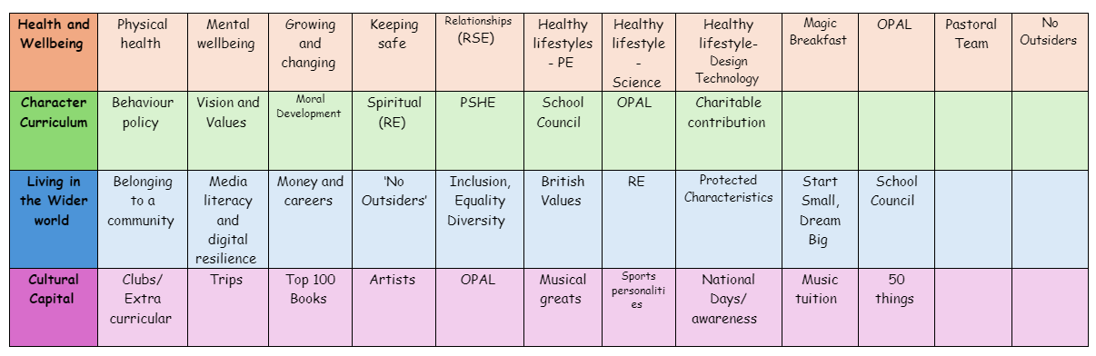
Media Literacy and Digital Resilience
Teaching children about media literacy and digital resilience is essential in today's technology-driven world, where children are constantly exposed to information, entertainment, and social media. These skills empower them to navigate the digital landscape thoughtfully, safely, and responsibly.
1. Critical Thinking and Information Evaluation
Media literacy helps children develop the ability to critically analyse the content they encounter online. They learn to question the reliability, accuracy, and source of information. With so much misinformation, fake news, and biased content online, this skill is crucial to prevent children from being misled or manipulated by false narratives.
2. Building Healthy Digital Habits
Teaching digital resilience encourages children to develop a healthy relationship with technology. It helps them understand the importance of balancing screen time with other activities, practicing self-regulation, and recognizing when digital media is negatively impacting their mental health. By fostering these habits early, they learn how to use technology in a way that supports their well-being.
3. Understanding Online Safety and Privacy
Children need to understand the risks associated with the digital world, including issues like cyberbullying, online predators, and privacy concerns. Media literacy education helps children recognise these risks and teaches them how to protect themselves online. They learn to manage privacy settings, avoid sharing sensitive personal information, and spot harmful behaviours, making them safer digital citizens.
4. Developing Digital Resilience and Coping Skills
Digital resilience helps children handle challenges and adversity online, such as dealing with cyberbullying, online conflicts, or feeling overwhelmed by the pressures of social media. By teaching resilience, children learn how to bounce back from negative online experiences, maintain their self-esteem, and seek support when needed.
5. Promoting Positive Online Behaviour and Citizenship
Media literacy encourages children to understand the impact of their online actions. They learn to engage respectfully, responsibly, and kindly with others on social platforms. It promotes the importance of being a positive digital citizen, contributing to constructive conversations and respecting the rights and feelings of others.

6. Reducing the Impact of Social Media on Self-Esteem
Children often compare themselves to idealised or unrealistic images on social media, which can negatively affect their self-image. Media literacy education helps them understand that many images and videos are edited or curated to portray a certain "perfect" image. It helps them build resilience against these pressures and promotes body positivity and self-acceptance.
7. Developing a Balanced Perspective on Technology
Media literacy helps children understand both the positive and negative aspects of digital media. While technology can offer many benefits, such as access to knowledge, entertainment, and communication, it can also lead to negative experiences like screen addiction, exposure to harmful content, or social isolation. A balanced perspective helps children make informed choices about when and how to engage with digital media.
8. Encouraging Creativity and Empowerment
Learning about media literacy empowers children to create and share content thoughtfully. It teaches them how to express themselves digitally in a positive way—whether it’s through blogs, videos, or social media. This fosters creativity and helps them build skills that will be valuable in their personal and professional lives in the future.
9. Navigating Digital Relationships
Digital media plays a central role in how children form and maintain relationships. Media literacy helps children understand the characteristics of online communication, including the potential for miscommunication and the importance of empathy. They learn how to engage in positive, supportive digital friendships and navigate conflicts constructively.
10. Preparing for Future Challenges
The digital landscape is constantly evolving, and teaching media literacy and digital resilience equips children with the tools to adapt. They will face new technologies, platforms, and challenges as they grow. By learning these skills early, children are better prepared to face future technological shifts with confidence and adaptability.
11. Encouraging Mindful Consumption
Media literacy encourages children to reflect on their media consumption habits. It helps them understand the influence that media can have on their thoughts, behaviours, and opinions. By teaching them to be mindful consumers of media, children become more selective about what they watch, read, and share, leading to healthier media habits and reduced exposure to harmful content.
12. Supporting Emotional Well-Being
Digital resilience includes learning to manage the emotional impact of online experiences. For instance, children learn how to respond to negative comments or interactions on social media without internalising them. This emotional regulation helps children build stronger mental health and reduces the chances of feeling anxious, depressed, or isolated because of digital interactions.

Teaching media literacy and digital resilience gives children the tools to become critical, informed, and responsible users of digital technology. It helps them navigate the complexities of the digital world safely and thoughtfully, protecting their emotional well-being and empowering them to make positive contributions online. These skills also prepare them for a future where digital media will continue to play a major role in their personal, academic, and professional lives.

The following is the progression document in place to teach media literacy and digital literacy in dedicated PSHE lessons.
Year 1

- how and why people use the internet
- the benefits of using the internet and digital devices
- how people find things out and communicate safely with others online
Year 2

- the ways in which people can access the internet e.g. phones, tablets, computers
- to recognise the purpose and value of the internet in everyday life
- to recognise that some content on the internet is factual and some is for entertainment e.g. news, games, videos
- that information online might not always be true
Year 3

- how the internet can be used positively for leisure, for school and for work
- to recognise that images and information online can be altered or adapted and the reasons for why this happens
- strategies to recognise whether something they see online is true or accurate
- to evaluate whether a game is suitable to play or a website is appropriate for their age-group
- to make safe, reliable choices from search results
- how to report something seen or experienced online that concerns them e.g. images or content that worry them, unkind or inappropriate communication
Year 4

- that everything shared online has a digital footprint
- that organisations can use personal information to encourage people to buy things
- to recognise what online adverts look like
- to compare content shared for factual purposes and for advertising
- why people might choose to buy or not buy something online e.g. from seeing an advert
- that search results are ordered based on the popularity of the website and that this can affect what information people access
Year 5

- to identify different types of media and their different purposes e.g. to entertain, inform, persuade or advertise
- basic strategies to assess whether content online (e.g. research, news, reviews, blogs) is based on fact, opinion, or is biased
- that some media and online content promote stereotypes
- how to assess which search results are more reliable than others
- to recognise unsafe or suspicious content online
- how devices store and share information
Year 6

- about the benefits of safe internet use e.g. learning, connecting and communicating
- how and why images online might be manipulated, altered, or faked
- how to recognise when images might have been altered
- why people choose to communicate through social media and some of the risks and challenges of doing so
- that social media sites have age restrictions and regulations for use
- the reasons why some media and online content is not appropriate for children
- how online content can be designed to manipulate people’s emotions and encourage them to read or share things
- about sharing things online, including rules and laws relating to this
- how to recognise what is appropriate to share online
- how to report inappropriate online content or contact

