
Personal Development Curriculum
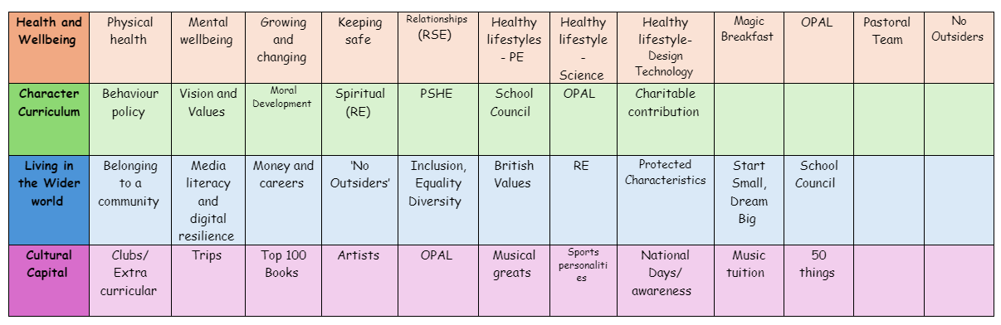
Belonging to a community
Teaching children about belonging to a community is essential because it helps them develop critical social, emotional, and moral skills that are fundamental for their personal growth and their ability to navigate the world around them.
1. Fostering Social Skills and Connection
Belonging to a community teaches children how to interact with others, collaborate, and build meaningful relationships. It helps them understand the importance of cooperation, communication, and mutual respect. These skills are key to making friends, resolving conflicts, and forming healthy relationships throughout their lives.
2. Building a Sense of Responsibility
When children feel part of a community, they learn that their actions affect others. This sense of belonging instils a sense of responsibility—whether it’s taking care of shared spaces, helping others, or contributing to a common goal. It helps them understand the impact of their behaviour and encourages them to be more mindful of their actions.
3. Promoting Empathy and Compassion
Being part of a community helps children develop empathy and compassion as they recognise that other people have different needs, experiences, and challenges. When they understand that everyone in the community has a role to play, they become more sensitive to others’ feelings and learn how to help and support each other.
4. Boosting Self-Esteem and Confidence
Feeling like they belong gives children a sense of acceptance and validation, which boosts their self-esteem and confidence. When children are part of a supportive community, they feel valued and appreciated for who they are, which builds a positive sense of self-worth.
5. Teaching Shared Values and Morals
Communities often have shared values, such as kindness, fairness, and respect. By being part of a community, children learn these values in a practical, real-world context. They understand that what’s good for the group is good for the individual, and this shapes their moral compass and ethical decision-making.

6. Encouraging a Sense of Belonging and Security
A sense of belonging is a powerful factor in a child’s emotional development. It provides them with a safe and supportive environment where they feel secure and understood. This sense of security is crucial for their well-being, as it gives them the emotional foundation to explore, take risks, and develop their full potential.
7. Promoting Cooperation and Teamwork
Belonging to a community teaches children the importance of teamwork. They learn how to share responsibilities, compromise, and collaborate toward shared goals. These skills are not only important for social success but also for academic and professional achievement later in life.
8. Encouraging Civic Engagement and Active Participation
When children learn about community, they are often encouraged to participate in activities such as helping with local projects, volunteering, or contributing to causes they care about. This teaches them the importance of civic engagement and being active, responsible citizens who contribute to society.
9. Helping Children Feel Less Isolated
Learning about community helps children understand that they are not alone. It creates a network of support where they can find help when needed and offer help when they can. This reduces feelings of isolation or loneliness and builds a strong foundation for emotional and social resilience.
10. Developing a Global Perspective
While communities often start locally, learning about belonging can also broaden children’s understanding of the world. It helps them recognize the interconnectedness of people across different cultures, backgrounds, and countries. This global awareness fosters tolerance, acceptance, and a broader sense of responsibility toward others.
11. Instilling Long-Term Well-Being
Children who learn to be part of a community are more likely to carry these lessons into adulthood. The skills, values, and attitudes they develop in early life will influence how they interact with others, work in teams, and engage with society throughout their lives. A strong sense of belonging can contribute to lifelong well-being, happiness, and success.
In short, teaching children about belonging to a community helps them grow into caring, responsible, and connected individuals. It lays the foundation for their social, emotional, and moral development, making them more likely to lead fulfilling and meaningful lives, both personally and in their relationships with others.

The following is the progression document in place to teach belonging to a community in dedicated PSHE lessons.
Year 1

- about examples of rules in different situations, e.g. class rules, rules at home, rules outside
- that different people have different needs
- how we care for people, animals and other living things in different ways
- how they can look after the environment, e.g. recycling
Year 2

- about being a part of different groups, and the role they play in these groups e.g. class, teams, faith groups
- about different rights and responsibilities that they have in school and the wider community
- about how a community can help people from different groups to feel included
- to recognise that they are all equal, and ways in which they are the same and different to others in their community
Year 3

- the reasons for rules and laws in wider society
- the importance of abiding by the law and what might happen if rules and laws are broken
- what human rights are and how they protect people
- to identify basic examples of human rights including the rights of children
- about how they have rights and also responsibilities
- that with every right there is also a responsibility e.g. the right to an education and the responsibility to learn
Year 4

- the meaning and benefits of living in a community
- to recognise that they belong to different communities as well as the school community
- about the different groups that make up and contribute to a community
- about the individuals and groups that help the local community, including through volunteering and work
- how to show compassion towards others in need and the shared responsibilities of caring for them
Year 5

- about how resources are allocated and the effect this has on individuals, communities and the environment
- the importance of protecting the environment and how everyday actions can either support or damage it
- how to show compassion for the environment, animals and other living things
- about the way that money is spent and how it affects the environment
- to express their own opinions about their responsibility towards the environment
Year 6

- what prejudice means
- to differentiate between prejudice and discrimination
- how to recognise acts of discrimination
- strategies to safely respond to and challenge discrimination
- how to recognise stereotypes in different contexts and the influence they have on attitudes and understanding of different groups
- how stereotypes are perpetuated and how to challenge this

