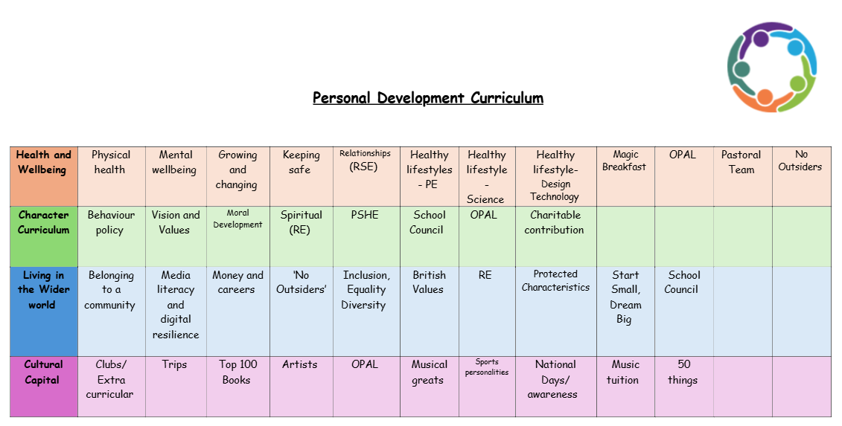
Charitable contribution
Children making charitable contributions can play a key role in developing their character and enriching their overall curriculum. It provides opportunities for them to practice core values and virtues, while also helping them grow emotionally, socially, and morally.
1. Developing Empathy and Compassion
When children engage in charitable activities—whether it's donating clothes, volunteering time, or raising funds—they begin to understand the challenges faced by others. This helps them develop empathy and compassion, as they learn to recognise and respond to the needs of people in their community or even around the world.
2. Teaching Responsibility
By making charitable contributions, children learn about responsibility—not just for themselves, but for others as well. It teaches them that their actions can positively impact those who are less fortunate, fostering a sense of social responsibility. They also begin to understand the importance of sharing what they have with those in need.
3. Promoting Gratitude
Charitable contributions often encourage children to reflect on what they have and appreciate it. Whether they are donating their toys, clothes, or time, children come to understand how fortunate they are, which cultivates gratitude. This, in turn, encourages them to value what they have and not take things for granted.
4. Instilling a Sense of Community
Charitable acts help children feel part of a larger community. By giving to others, they realize the importance of collaboration and how working together can create positive change. This sense of belonging can help build social skills, as children are encouraged to think beyond themselves and care about the well-being of others.

5. Building Integrity and Honesty
Charity work often requires children to follow through on their commitments and actions, whether it's organising the receiving of food or money donations or volunteering to run cake sale. These tasks help build integrity, as children learn to keep promises, be honest, and act with a sense of moral purpose.
6. Teaching Altruism and Selflessness
One of the key lessons from charitable contributions is the idea of giving without expecting anything in return. Children learn the value of altruism, understanding that doing good for others is a reward in itself. This teaches selflessness and the joy that comes from making a positive difference in someone else’s life.
7. Encouraging Teamwork and Collaboration
Many charitable activities involve working with others, whether it's organising a fundraiser or collecting donations as a group. This teaches teamwork, collaboration, and leadership skills. Children learn how to cooperate, share responsibilities, and contribute to a common goal.
8. Building Confidence and Leadership Skills
Charitable actions often require children to take initiative and lead efforts, such as organising a collection or encouraging peers to participate in a cause. Taking ownership of a charitable project builds leadership skills and boosts their self-confidence as they see the positive impact of their efforts on others.
9. Strengthening Moral and Ethical Values
Charitable contributions are a practical way for children to learn important moral values such as fairness, justice, and kindness. They come to understand the significance of helping those in need, upholding ethical standards, and standing up for the most vulnerable members of society.
10. Instilling a Lifelong Commitment to Giving
By introducing children to charitable contributions early on, we help establish a mindset of giving that can last throughout their lives. This encourages them to become active, compassionate members of society, who will continue to contribute positively to their communities as they grow older.

In essence, charitable contributions help children develop into well-rounded individuals with strong ethical foundations. By fostering virtues like empathy, responsibility, and selflessness, it helps shape their character and encourages them to be caring and thoughtful citizens of the world.

