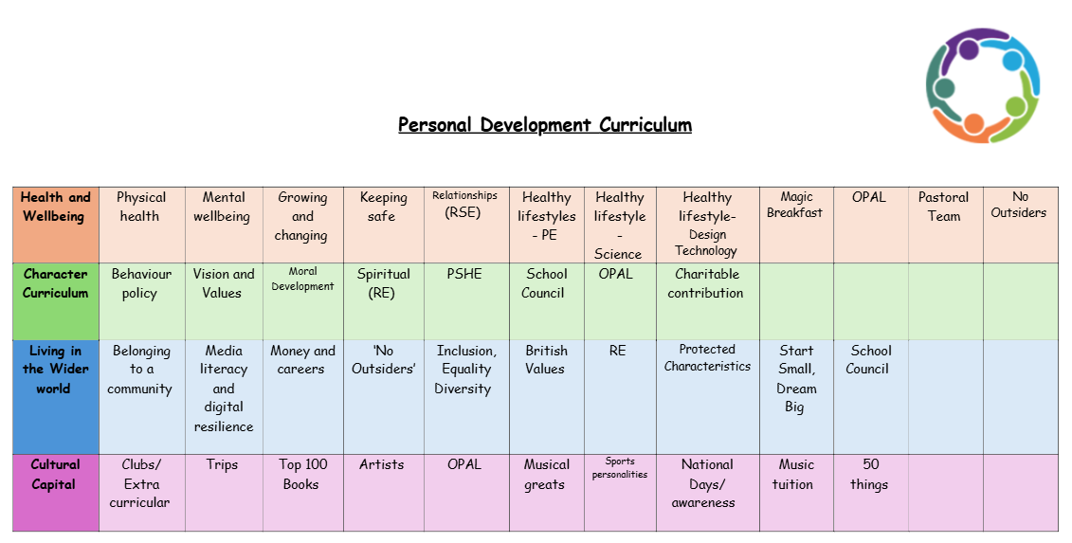

OPAL- character development
OPAL (outdoor play and learning) can have a significant positive impact on children's character development and curriculum.
1. Fostering Independence and Confidence
Outdoor play often allows children to make decisions on their own, whether it's choosing a game to play, navigating physical challenges, or solving problems. This independence boosts self-confidence and helps them develop a sense of responsibility.
2. Encouraging Teamwork and Cooperation
Many outdoor activities, like group games, sports, or collaborative tasks (e.g., building a fort), require children to work together. This fosters social skills like teamwork, communication, empathy, and conflict resolution, all of which are essential components of character development.
3. Enhancing Problem-Solving Skills
In nature or outdoor environments, children are often presented with real-world challenges (e.g., balancing on uneven ground, figuring out how to build a shelter, or navigating obstacles). These situations develop their critical thinking and problem-solving abilities, teaching them to be resourceful and persistent.
4. Promoting Resilience and Grit
Outdoor play involves physical activity, often with minor risks or failures (like falling, getting wet, or facing weather challenges). This helps children learn how to cope with setbacks, persevere, and become more resilient in the face of difficulties, fostering grit and emotional fortitude.

5. Instilling a Sense of Responsibility
Whether it's taking care of outdoor spaces, looking after plants, or being mindful of the environment, outdoor play often brings with it a sense of responsibility. Children learn to respect their surroundings, clean up after themselves, and take care of shared resources, instilling a sense of duty.
6. Developing Leadership Skills
Outdoor play often puts children in leadership roles, where they might need to guide others or make decisions for a group. These experiences allow children to develop skills like leading by example, encouraging others, and making thoughtful decisions.
7. Building Patience and Self-Regulation
Outdoor play often requires children to wait their turn, follow rules, or take time to complete tasks, which can improve patience and impulse control. The slower pace of nature or outdoor exploration encourages children to focus and reflect, supporting emotional regulation.
8. Fostering a Growth Mindset
By encountering challenges outdoors and working through them, children develop a growth mindset—the belief that abilities and intelligence can be developed through effort. This mindset is key to lifelong learning and resilience.
9. Encouraging Creativity
The natural environment encourages creative thinking. Whether children are making up games, building structures from natural materials, or imagining stories based on the surroundings, outdoor play stimulates creativity and imagination, which are vital parts of character and cognitive growth.
10. Building a Connection to Nature and Respect for Life
Spending time outdoors helps children develop an appreciation for the environment and a sense of interconnectedness with nature. This can lead to the development of virtues like respect, care for the planet, and a sense of stewardship.
Incorporating outdoor learning and play into a child’s curriculum not only benefits their physical health but also plays a crucial role in developing character traits such as responsibility, empathy, patience, and resilience.

