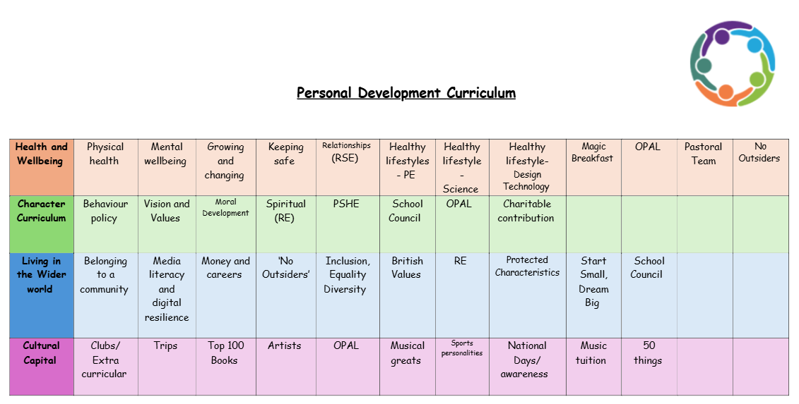
School Council
Doxey Academy’s School Council is a group of students elected by their classmates to represent the views and interests of all the pupils who attend Doxey Academy. The School Council meets regularly to discuss school-related matters, such as improving the school environment, organising events, or addressing concerns raised by students. Members of the School Council learn valuable skills such as leadership, communication, and teamwork while contributing to the development of their school community.
Our school council demonstrates democracy, a core British Value, by giving pupils a choice to voice their opinions and take part in decision-making processes. This opportunity to be a member of the school council encourages a sense of responsibility, as the pupils can see that their votes and ideas can influence school life. The school council also teaches pupils about fairness, debate, and consensus. This replicates the democratic processes in society and supports in preparing our pupils for life in the wider world.

In 2023-2024 the School Council:
- Contributed to the new behaviour system and policy.
- Participated in the design for the new, inspirational mural in the centre of the school.
- Gathered pupil’s thoughts and views about the current playground and what pupils would like to access on the playground at lunchtimes.
- Supported the OPAL (Outdoor Play and Learning) Team with designing the new provision on the playground.
- Arranged a charity event for BBC Children in Need.
- Gathered pupil’s ideas about events they would like throughout the school year.
- Contributed to the design of the new library and the displays within the library.

