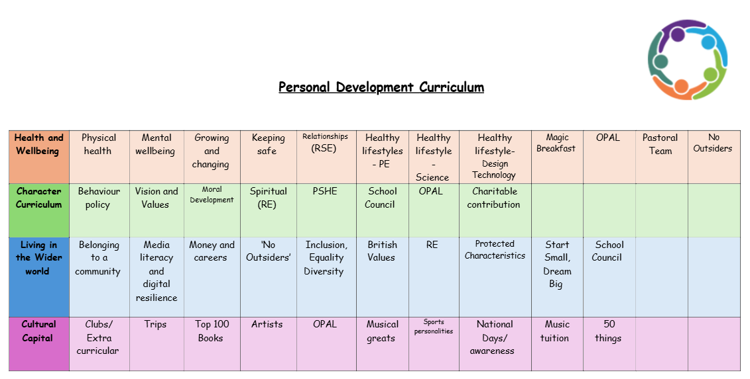
PSHE Curriculum
At Doxey Primary School we know that the teaching of PSHE is paramount to the success of our children. Our PSHE curriculum allows our pupils to study aspects of life that will help them thrive in the complex and challenging world we live in. We give them the opportunities to think about different areas of life, discuss issues and learn key skills in a safe environment before encountering them in the wider world.
We follow a spiral curriculum which introduces new and challenging learning, whilst building on what has been taught before. To guarantee that our pupils are ready for life in secondary school we ensure they are confident in understanding relationships, friendships, and interactions. We make sure they can manage conflicts and resolve disputes, as well as making choices, manging risks, and staying safe in all areas of life. We introduce our pupils to the world of work and encourage them to have high aspirations in this area.

