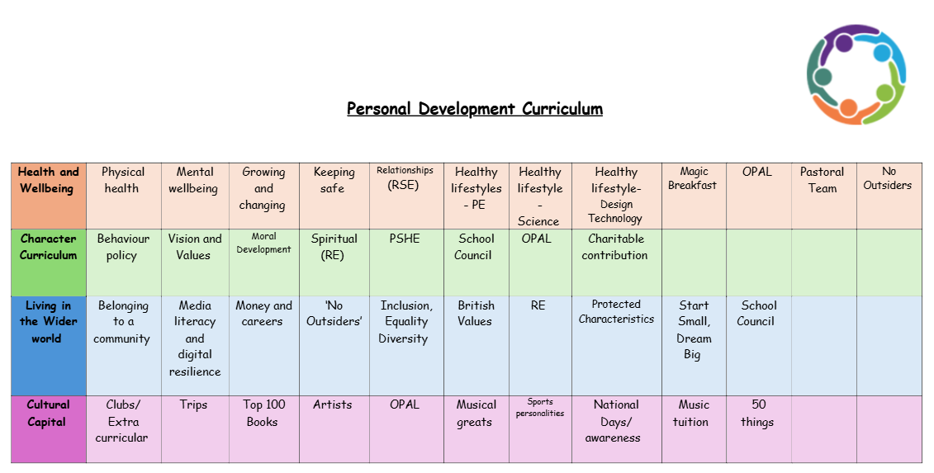
Spiritual Development- Religious Education
At Doxey, our mission is to prepare every pupil for life in today’s diverse Britain through a comprehensive Religious Education (RE) curriculum. RE holds a pivotal role in our broad curriculum, enriching pupils’ knowledge and understanding of various religious and non-religious worldviews. We aim to nurture each pupil's development of their own values, identity, and worldview, both within their cultural heritage and the broader societal context.
Our carefully structured curriculum ensures that children gain relevant, age-appropriate, and progressive skills and substantial knowledge each year. By revisiting previous lessons and vocabulary, we empower pupils to think independently and develop the skills needed to formulate their own worldviews. Incorporating literature, art, and music from various traditions, we enrich cultural capital and challenge stereotypes. We foster curiosity and enthusiasm for learning about different cultures through interactions with diverse individuals and discussions on religious vocabulary.
Our inclusive curriculum offers rich opportunities to explore, engage, and reflect on different beliefs. Through interactive lessons, workshops, guest speakers, Nativity performances, and visits to places of worship, children gain a deep understanding and appreciation of various backgrounds and faiths. Immersing children in religious traditions and cultural celebrations helps them understand and respect both differences and similarities.
We aim for our children to dream big and formulate their own views and values, alongside our school’s core values of resilience, kindness, self-belief, integrity, and ambition. Pupils leave Doxey able to express their views respectfully and recognise and confront negative attitudes towards diversity. These positive attributes ensure their success and personal self-development.
Our RE curriculum helps pupils respect themselves, understand their identity, and respect others. They learn about rights and responsibilities, gaining balanced religious literacy and oracy. Confident in discussing different religions and viewpoints, they show tolerance and respect for others' beliefs. By the end of Year 6, pupils will possess the tools necessary to become responsible, empathetic, knowledgeable, and kind young adults who are well-prepared to thrive in a complex world, with a love for learning RE.

