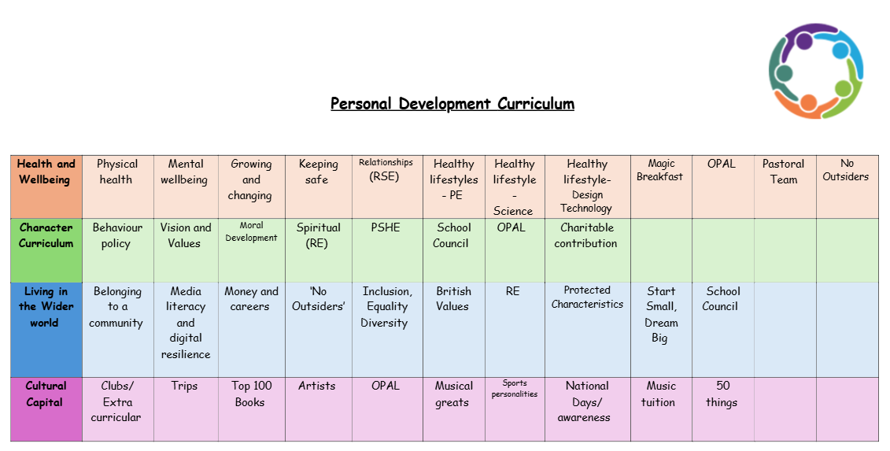
Moral Development
Moral development at Doxey Academy refers to the process through which young children learn to distinguish right from wrong, develop a sense of fairness and justice, and understand the effects of their actions on others. It encompasses a child’s ability to make ethical decisions, act responsibly, and cultivate empathy, kindness, and respect.

1. Developing Ethical Awareness
Right vs. Wrong: As children begin to understand basic moral concepts, such as honesty, fairness, and kindness, they are better equipped to make ethical choices. Recognising the difference between right and wrong is crucial for their overall sense of integrity and responsibility.
Guided Reflection: Teachers at Doxey Academy guide children to reflect on their actions, whether they made a good or poor decision, and why. This reflective practice enhances their moral reasoning, helping them become more aware of their impact on others.
This helps children develop a strong sense of self-awareness, as they can evaluate their own actions and learn from their experiences, which encourages growth and maturity.

2. Cultivating Empathy and Compassion
Understanding Others’ Feelings: Children learn to empathise with others by recognizing and understanding how their peers feel. Through interactions with others, such as playing with classmates or resolving conflicts, children develop the ability to put themselves in someone else’s shoes and appreciate different perspectives. Teachers guide pupils through this process as it happens, but taught sessions in PSHE also help pupils to understand this.
Positive Peer Relationships: Moral development encourages children to show kindness, offer help to others, and recognise the importance of supportive friendships.
Empathy helps children build stronger relationships, resolve conflicts in peaceful ways, and become more emotionally intelligent, improving their social and emotional skills.

3. Encouraging Fairness and Justice
Learning Fairness: Children begin to grasp the importance of fairness—whether in games, dividing resources, or handling disagreements. They learn that everyone should be treated with equal respect and consideration.
Understanding Consequences: They understand that actions have consequences, both for themselves and others. Learning about fairness encourages them to respect rules, avoid selfish behaviour, and make decisions that contribute to a sense of equity. Pupils at Doxey Academy understand, and follow, our behaviour policy which clearly shows that not following our rules will result in a consequence. Teachers then ensure they explain this to pupils afterwards.
A strong sense of justice helps children develop integrity and a commitment to treating others with fairness, building their character and moral compass.

4. Developing Responsibility and Accountability
Taking Responsibility for Actions: Moral development encourages children to take responsibility for their behaviour, whether it’s following rules or admitting to mistakes. Understanding that their actions affect others makes children more accountable and aware of the consequences of their choices.
Building Self-Control: Learning to manage impulses, resist peer pressure, and act responsibly are important components of moral development. Children learn to make thoughtful decisions that align with ethical values, even when they face challenges. This is taught carefully, and considerately, during PSHE sessions as well as being taught to individual if, and when, it appears in their lives.
This fosters self-discipline and personal growth, as children develop the ability to regulate their behaviour and make positive choices independently.

5. Conflict Resolution and Problem-Solving
Learning to Resolve Disagreements: Children learn to solve problems and resolve conflicts in ways that are respectful and fair to all parties involved. Restorative practices in schools, such as discussions about how to repair relationships after a conflict, promote collaboration and understanding.
Building Communication Skills: As children work through conflicts, they improve their communication skills—learning how to express themselves, listen to others, and find compromises.
Conflict resolution skills are vital for lifelong success. Children who learn to handle disagreements calmly and fairly become more resilient, adaptable, and confident in social situations.

6. Fostering a Growth Mindset
Understanding Mistakes as Learning Opportunities: In moral development, children learn that making mistakes is part of the learning process. Instead of focusing solely on punishment, they are encouraged to understand the reasons behind their actions, reflect on what went wrong, and think of ways to improve.
Promoting Positive Behaviour: Teachers encourage children to model good behaviour and praise positive choices.
This encourages children to adopt a growth mindset, where they view challenges as opportunities for learning and personal development. This mindset fosters resilience, perseverance, and a desire to improve over time.

7. Building a Strong Moral Identity
Internalising Values: As children navigate through moral dilemmas and interact with their peers, they start internalising values such as honesty, responsibility, and respect. These values help shape their identity and guide their decision-making throughout their lives.
Role Models and Guidance: Teachers, parents, and other role models play a significant role in shaping children's moral development. By seeing adults demonstrate good moral behaviour, children begin to adopt those values and apply them in their own lives.
Developing a strong moral identity helps children feel confident in their choices and actions, and allows them to make decisions that align with their values as they grow into young adults.

Moral development at Doxey Academy lays some of the foundation for children’s emotional, social, and ethical growth. It supports their personal development by teaching them important life skills such as empathy, responsibility, fairness, self-control, and conflict resolution. These skills are crucial not only for building positive relationships with others but also for helping children develop a strong sense of self-worth, confidence, and integrity.

