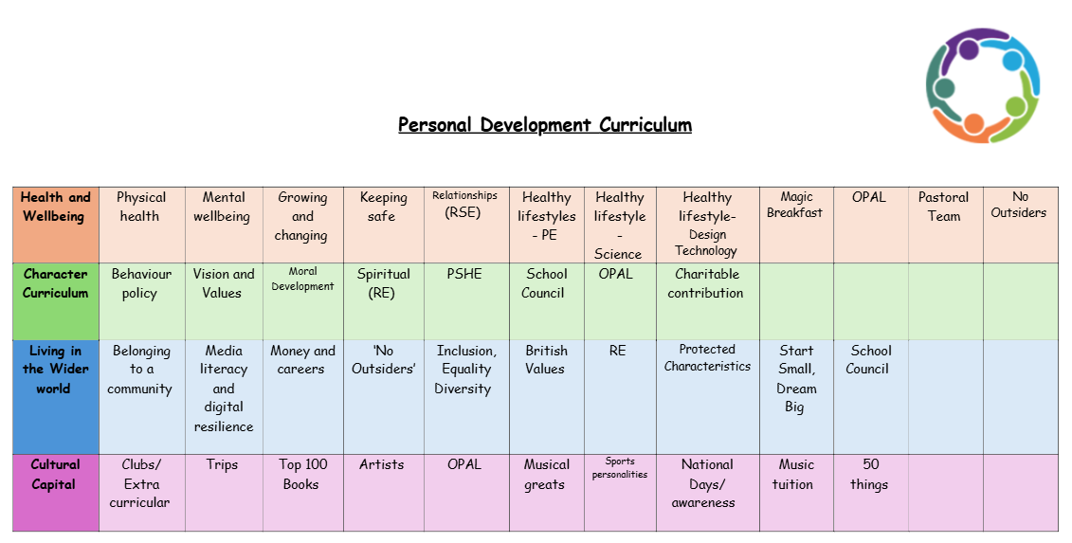
Vision
Our aim is for all our children to be aspirational in all aspects of their lives, both now and in the future. We encourage our children to dream big and we give them everything they need to make those dreams become a reality. We break down barriers both socially and academically to ensure that all of our children have the ambition, opportunities, knowledge and skills required to achieve the best outcomes in life.

Our children will leave our school with a high academic achievement, treasured memories, and ultimately a life-long joy of learning. Equally as important is that our children are well-rounded individuals with a clear sense of identity and individuality. We want them to have positive self-esteem, great ambition for themselves and a strong internal motivation to embark upon any path in life they wish to. We want them to make good choices and to be intrinsically driven to do the right thing, even when they face adversity. They will be proud of their community and make a positive contribution to society. Throughout their time with us they will have learnt to celebrate differences and show empathy to everyone they encounter in life.

When our children enter secondary school, we want them to have the confidence, motivation and skills to thrive within a new setting. The range of opportunities and experiences will give them this. They will be well placed to continue to build on the positive relationships they have already formed and have the skills to manage their own well-being and emotions. The lessons we have taught them will extend far beyond our classroom walls. Within their journey into the wider world, we want our values to shine through so that our children can make a positive contribution to society and have the capability to achieve social mobility.

