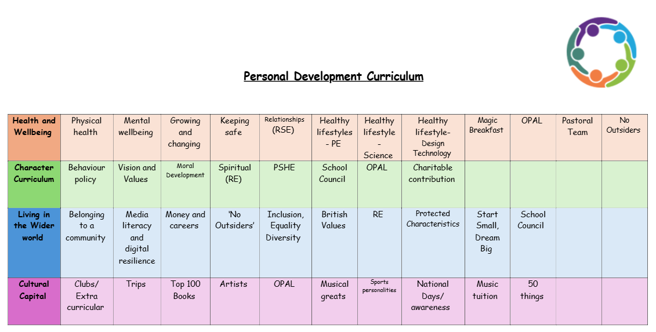
Values
Self-belief
Teaching self-belief is crucial because it helps children develop the confidence and resilience they need to succeed academically, socially, and emotionally. When children believe in themselves, they are more likely to take on challenges, persist through difficulties, and develop a positive attitude toward learning and personal growth.
1. Boosts Academic Success
Self-belief is closely tied to a growth mindset, the belief that abilities and intelligence can be developed with effort and practice. Children who believe in themselves are more likely to approach learning with a positive attitude, embrace challenges, and keep going even when they struggle.
When children believe they can succeed, they are more motivated to try their best. They are willing to put in the effort required to achieve academic goals, whether it’s tackling a difficult math problem, reading a challenging book, or participating in class discussions.
2. Builds Resilience
Self-belief empowers children to bounce back from failures and setbacks. Instead of being discouraged by mistakes, children with self-belief view challenges as opportunities to learn and grow. They understand that failure is a natural part of the learning process and that persistence is key to success.
When children believe in their ability to solve problems, they are more likely to approach obstacles with a can-do attitude. This encourages them to try different strategies and find solutions independently, rather than giving up when faced with difficulty.
3. Enhances Self-Esteem
Children with self-belief develop a positive sense of self-worth. When they believe in their abilities, they feel more confident in themselves, which boosts their overall self-esteem. This positive self-image is essential for their emotional well-being and helps them navigate social interactions more easily.
Teaching children to believe in themselves helps them overcome feelings of self-doubt. This is particularly important during the primary school years when children are still developing their sense of identity and self-worth.
4. Promotes Social Confidence
Children who believe in themselves are more likely to participate in classroom activities, ask questions, contribute to discussions, and engage in social interactions with their peers. Self-belief gives children the confidence to speak up and share their ideas without fear of judgment.
Children with self-belief are often more comfortable interacting with others. They are more likely to initiate friendships, join group activities, and collaborate with peers because they feel secure in themselves. This social confidence helps children build stronger, more positive relationships with others.
5. Instils a Sense of Independence
When children believe in their ability to make decisions and handle challenges, they are more likely to take responsibility for their actions and choices. They begin to trust their judgment and develop a sense of independence, which is crucial for their personal growth.
Children with self-belief are more likely to advocate for themselves in different situations, whether it’s asking for help when needed or expressing their needs and opinions. This self-advocacy is an important skill for navigating both academic and personal challenges.
6. Encourages Goal Setting and Achievement
When children believe they can achieve their goals, they are more likely to set and pursue them. Self-belief helps children set realistic but ambitious goals, whether it’s improving their reading skills, mastering a new math concept, or learning a new sport.
With self-belief, children understand that achieving their goals takes time and effort. They are more likely to stick with a task, even when it gets challenging, because they believe that their hard work will eventually pay off.
7. Promotes Positive Mental Health
Children who believe in their abilities tend to experience less anxiety about schoolwork or social situations. They approach challenges with confidence rather than fear, which helps reduce stress and promotes a more positive outlook on life.
Self-belief contributes to emotional stability by helping children manage their emotions more effectively. When they believe they can cope with difficult situations, they are less likely to be overwhelmed by negative emotions such as frustration, disappointment, or sadness.
8. Prepares Children for Future Challenges
Children who develop self-belief at a young age are more likely to approach learning as an ongoing process rather than something to be feared. This mindset helps them embrace new challenges and continue learning throughout their lives.
As children grow, they will face new challenges in school, at home, and in their future careers. Self-belief equips them with the confidence to handle transitions, overcome obstacles, and adapt to new situations.
We encourage self-belief by:
- Praising children for trying their best, taking risks, and making progress, even if the results aren’t perfect.
- Helping children set small, attainable goals that they can work toward.
- Giving children opportunities to succeed in various activities, whether it’s academics, sports, or creative tasks.
- Helping them view mistakes as learning opportunities rather than failures, reinforcing the idea that perseverance leads to growth.

