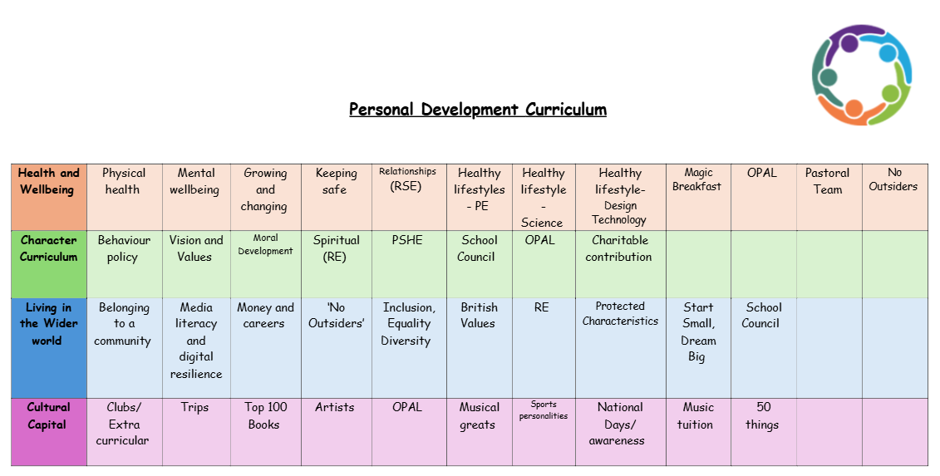
Values
Resilience
Resilience is an essential quality for children to develop, especially during their primary school years. It refers to the ability to bounce back from challenges, setbacks, or failures and keep going with a positive attitude. Teaching and nurturing resilience at Doxey Academy is important for many reasons, as it has long-term benefits for a child's personal, academic, and social growth.
1. Helps Children Cope with Challenges
Primary school children face various challenges, whether it’s difficulty with schoolwork, social conflicts, or personal struggles. Teaching our pupils to show resilience helps them stay calm, problem-solve, and persist through tough situations instead of giving up or becoming overwhelmed.
Building resilience enables children to manage their emotions when things don't go as planned, such as feeling frustrated or disappointed. This emotional regulation helps them remain focused on finding solutions rather than getting stuck in negative feelings. Our staff support pupils with their emotional regulation in class situations, or through the pastoral team.
2. Fosters a Growth Mindset
Resilient children view mistakes as learning opportunities rather than failures. This mindset shift is crucial for helping them embrace challenges, persist through difficulties, and ultimately improve their skills and understanding over time. In all lessons, when an error is made the teacher uses it as a teaching point, encouraging all pupils to reflect and learn from the mistake.
With resilience, children are more likely to try again after setbacks, knowing that effort and persistence can lead to improvement. This helps them develop a sense of accomplishment and pride in their ability to grow and achieve.
3. Builds Confidence and Self-Esteem
As children encounter and overcome difficulties, they build confidence in their abilities. The more resilient a child is, the more they understand that they can take on challenges and succeed.
Resilient children are less likely to be discouraged by failures. Instead, they feel more capable of tackling problems and learning from their mistakes, which strengthens their self-esteem.
4. Promotes Independence and Problem-Solving Skills
Resilient children are often more independent, as they learn to approach problems on their own and figure out solutions. They don't rely on others to fix their problems but instead think critically and take initiative. At Doxey Academy, we teach pupils about being independent and how to problem solve to then allow them to do this independently eventually.
Being resilient also helps children adapt to change, whether it’s a new school, a shift in routine, or a difficult situation with a classmate. Adaptability is a key skill for thriving in a constantly changing world. By teaching our pupils to be resilient, we are supporting them with transition they make to secondary school, and adult life.
5. Supports Social and Emotional Development
Primary school is a time when children are developing social skills, and resilience helps them manage the ups and downs of friendships and social interactions. Resilient children are better able to cope with rejection or peer conflicts and to bounce back from these experiences without letting them affect their self-worth.
Resilient children tend to have better emotional regulation. They are more able to manage stress, frustration, and disappointment in a healthy way, which is important for their overall emotional well-being.
6. Improves Academic Performance
In the classroom, children with resilience are more likely to persist when faced with academic challenges. They are less likely to give up on difficult tasks and more likely to put in the effort needed to succeed.
Resilience helps children develop the internal drive to keep trying, even when things get tough. This self-motivation encourages them to set and work toward academic goals, leading to improved outcomes.
7. Lays the Foundation for Future Success
Resilience learned in primary school sets the stage for future success, not just in school but in later life as well. Children who develop resilience are better equipped to handle the inevitable challenges and changes they will face throughout their lives.
Resilient children are more likely to be adaptable, proactive, and emotionally balanced as they grow, which are key skills for navigating the demands of adolescence, higher education, and eventually the workforce.
We encourage resilience by:
- Demonstrating how to overcome challenges by modelling this process to our pupils
- Staying calm and positive
- Praising effort and not just results
- Teaching the Power of “Yet”
- Giving pupils challenges and then support them through the process of solving them
- Promoting problem-solving and teach our pupils strategies to complete these
- Naming emotions when regulating alongside pupils
- Normalising failure by explaining how it is natural not to succeed at everything first time
- Discussing real-life role models, either famous faces or the individuals we welcome into assembly to talk about their career pathways and how they have overcome problems and showed resilience
- Creating a predictable environment so pupils know it is a safe place to overcome challenges

