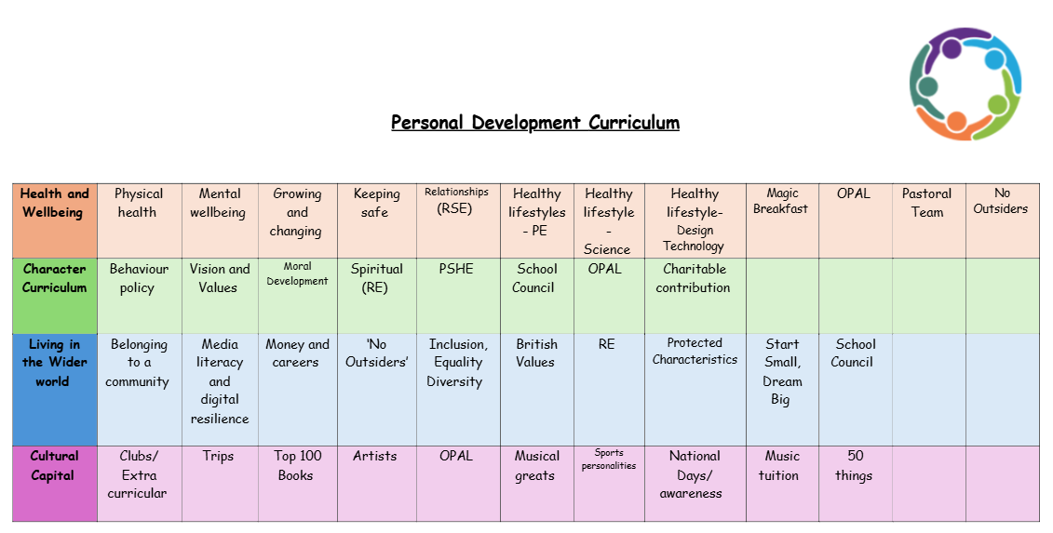
Values
Kindness
Kindness plays a vital role in shaping children's emotional, social, and academic development.
1. Builds Positive Relationships
Kindness helps children form meaningful friendships and positive relationships with their peers. When children are kind to each other, they build trust and create an environment of cooperation, respect, and mutual support.
A culture of kindness can help reduce bullying and exclusion by fostering an atmosphere where all students feel valued, respected, and included. When kindness is encouraged, children are more likely to treat others with compassion and empathy.
2. Fosters Emotional Well-Being
When children engage in acts of kindness, they often feel good about themselves, which boosts their self-esteem and confidence. They feel valued for their actions and the positive impact they have on others.
Kindness helps children develop empathy by encouraging them to understand and share the feelings of others. By showing compassion and care, children become more attuned to others’ emotions and learn to respond in supportive ways.
3. Supports Social and Moral Development
Kindness encourages teamwork and cooperation. Children who are kind to one another are more likely to work together, share ideas, and help each other succeed in group activities or academic projects.
Kindness teaches children respect for others and the responsibility to treat others with dignity. By learning to be kind, children also learn the importance of being fair and treating others equally.

4. Improves Classroom Atmosphere
When children are kind to each other, they create a classroom environment that is conducive to learning. A classroom where students feel safe, respected, and supported is more likely to foster creativity, collaboration, and open communication.
Kindness helps resolve conflicts in a peaceful and constructive way. Instead of engaging in arguments or fights, children who are taught kindness are more likely to approach conflicts with a calm, respectful attitude and seek solutions that benefit everyone.
5. Enhances Academic Success
When students experience kindness from their teachers and peers, they feel more motivated to participate and contribute to class activities. They are more likely to engage in lessons and feel a sense of belonging in the school community.
A kind and supportive atmosphere can help reduce school-related anxiety and stress. Children who feel accepted and encouraged by their peers and teachers are less likely to experience feelings of isolation or fear of failure.
6. Promotes Positive Behaviour and Character Development
Acts of kindness promote positive behaviour, such as sharing, helping others, and being considerate. These habits, when practiced regularly, become ingrained in children’s character and guide their actions throughout life.
Kindness is a core value that helps children build strong moral character. It teaches them to care for others and make ethical decisions based on compassion and understanding.
7. Encourages a Sense of Community
When kindness is emphasized, it helps build a sense of community within the school. Children feel that they are part of a larger network of support where everyone is valued and encouraged to contribute positively.
Kindness not only strengthens relationships between students but also between teachers, staff, and parents. A school culture that emphasizes kindness extends to all members of the community, creating a more harmonious and supportive environment.
8. Promotes Long-Term Positive Habits
Teaching kindness early in life encourages children to carry these values into adulthood. Children who practice kindness are more likely to grow up to be compassionate, thoughtful, and empathetic adults who contribute positively to society.
Kindness is a ripple effect. Children who practice kindness today are more likely to foster kindness in their communities as they grow. This creates a more compassionate, caring, and fair society in the long term.
We encourage kindness by:
- Leading by example as children learn by observing the behaviour of adults.
- Showing empathy when a pupil is struggling, whether emotionally or academically.
- Establishing classroom rules and expectations around kindness.
- Acknowledging and praising pupils when they demonstrate kindness.
- Teaching children to use restorative practices to repair relationships when conflict arises.
- Integrating lessons on kindness into discussions about bullying.

