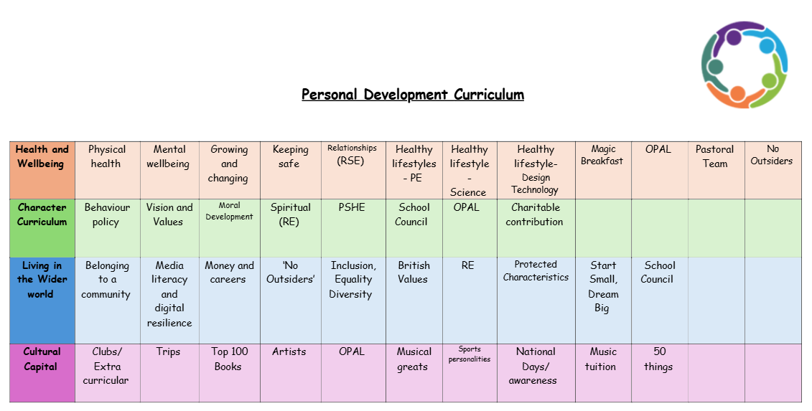
Values
Integrity
Integrity is a fundamental value that helps children develop honesty, responsibility, and a strong moral compass. At Doxey Academy was believe teaching integrity is essential because it lays the foundation for ethical behaviour throughout our lives.
1. Building Trust and Strong Relationships
Integrity involves being honest and truthful, which is crucial for building trust with peers, teachers, and family. Children who act with integrity are more likely to form strong, respectful relationships with others because people trust them to be truthful and reliable.
When children demonstrate integrity, they respect the feelings, ideas, and belongings of others. They understand that treating people fairly and ethically is the right thing to do, which helps them navigate social interactions with kindness and fairness.
2. Promoting Accountability and Responsibility
Integrity encourages children to take responsibility for their actions, including their mistakes. When children admit when they’ve done something wrong, it allows them to learn from their errors and grow as individuals.
Acting with integrity means children take their responsibilities seriously, whether it's completing schoolwork, keeping promises, or following through on tasks. This helps them become more dependable and conscientious individuals.
3. Encouraging Positive Decision-Making
Integrity helps children make decisions based on what is right, not just on what is easy or beneficial for them in the moment. Children with integrity are more likely to make ethical decisions, whether it’s in class, on the playground, or at home.
Integrity gives children the strength to resist peer pressure or the temptation to engage in dishonest behaviour, such as cheating or lying. It helps them stay true to their values, even when faced with challenges.
4. Supporting Academic Success
Children with integrity are more likely to approach their schoolwork honestly. They focus on learning and doing their best, rather than taking shortcuts, such as copying someone else's work or cheating on tests.
When children act with integrity in their academic efforts, they can feel proud of the work they do, knowing they earned their success through honest effort and perseverance.
5. Enhancing Self-Respect and Confidence
Acting with integrity helps children develop a strong moral character. They learn to align their actions with their values, which boosts their self-respect and confidence.
Children who act with integrity feel a sense of pride in their decisions because they know they are doing what is right. This positive self-image fosters emotional well-being and resilience.
6. Fostering a Positive School Environment
When children practice integrity, they contribute to creating a positive, respectful, and safe learning environment. Integrity helps to prevent bullying, dishonesty, and unfairness, allowing everyone to feel valued and respected.
Children who demonstrate integrity serve as positive role models for their peers. They set an example of how to behave ethically and treat others with kindness and fairness.
7. Developing Long-Term Ethical Values
Teaching integrity in primary school helps children form ethical values that will guide them throughout their lives. The lessons they learn about honesty, fairness, and responsibility become ingrained in their character and influence their future choices.
Integrity also helps children deal with tough situations in the future. When they face difficult decisions or challenges, they will be more likely to choose the path that aligns with their values, rather than making choices that compromise their ethics.
We encourage integrity by:
- Being a role model and ensuring we show integrity in our daily actions
- Demonstrating accountability. When we make a mistake, we own up to it and show how to apologise for our mistake
- Giving children responsibility such as classroom and school-wide jobs. We are teaching the children to be trustworthy.
- Praising when pupils made decision which show integrity- telling the truth etc…
- Creating an environment where children feel comfortable to express their thought and admit mistakes
- Encourage pupils to show forgiveness and accept apologies

