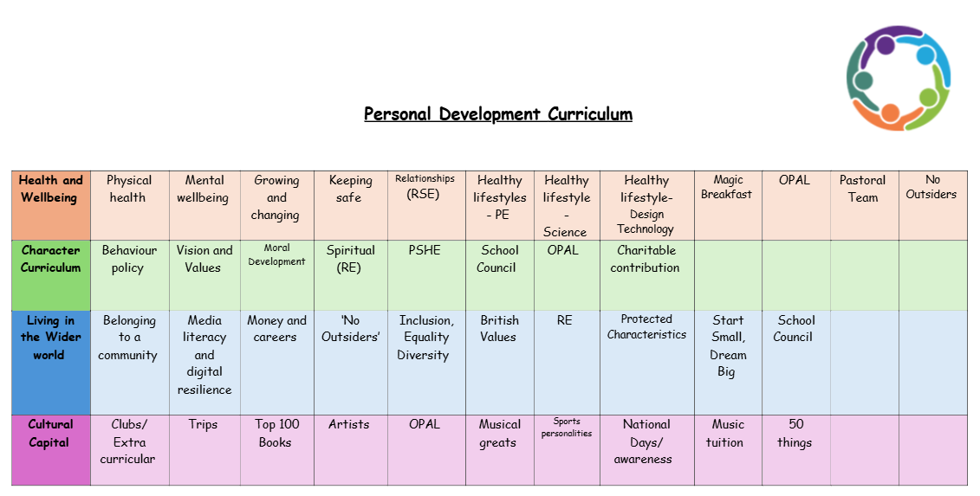
Values
Ambition
Teaching ambition is important because it helps set the foundation for children's future success and personal development. Ambition encourages children to set goals, work hard, and strive for personal excellence. When taught early, it can shape their attitudes toward learning, resilience, and achievement.
1. Encourages Goal Setting and Achievement
Ambition helps children develop a clear sense of direction. When children understand the importance of setting goals, they are more likely to take ownership of their learning and work purposefully toward achieving those goals. This can be academic, social, or personal.
Ambitious children are motivated to put in the effort required to achieve their dreams and aspirations. Instead of giving up when things get tough, ambition drives them to keep going and strive for improvement, leading to a sense of accomplishment when they reach their goals.
2. Promotes Resilience and Persistence
Ambitious children learn that achieving their dreams requires hard work and overcoming obstacles. When they face setbacks, they’re more likely to view them as temporary hurdles rather than insurmountable barriers. This mindset helps develop resilience and perseverance.
Children with ambition often adopt a growth mindset—the belief that abilities and intelligence can improve with effort and persistence. When they face difficulties, they understand that challenges are part of the learning process and are an opportunity to grow.
3. Develops Confidence and Self-Esteem
When children are encouraged to be ambitious, they begin to believe in their potential to achieve great things. Setting and working toward goals builds their self-confidence and helps them develop a positive self-image.
As children achieve their goals, whether big or small, they experience a sense of pride and accomplishment. This boosts their self-esteem and reinforces the idea that hard work and ambition can lead to success.
4. Encourages a Lifelong Learning Mindset
Ambition in primary school encourages children to ask questions, seek answers, and explore new ideas. This curiosity is a key driver of lifelong learning. Ambitious children are motivated to continuously improve themselves, both academically and personally.
Children who are taught to be ambitious are more likely to take their schoolwork seriously and actively engage in learning. They understand that education is a pathway to achieving their goals, which makes them more motivated to perform well in school.
5. Prepares Children for Future Success
Pursuing ambitious goals requires children to manage their time effectively, prioritize tasks, and stay organized. These skills are vital for academic success and will serve them throughout their lives, both in school and in their future careers.
Ambitious children learn to stay focused on their goals and resist distractions. They develop self-discipline, which is essential for success in any area of life, whether it’s education, career, or personal relationships.
6. Builds Problem-Solving and Critical Thinking Skills
Ambitious children often think outside the box when trying to achieve their goals. They develop problem-solving skills by finding innovative solutions to obstacles they encounter along the way.
Children with ambition learn to weigh their options and make informed decisions to move closer to their goals. They begin to understand that their actions have consequences, and they learn to take responsibility for their choices.
7. Promotes Positive Attitudes Toward Failure
When ambition is taught alongside resilience, children begin to view failure not as a negative outcome, but as a valuable learning experience. Ambitious children understand that failure is a natural part of growth, and it’s an opportunity to learn and improve for the future.
With ambition comes the willingness to take calculated risks. Children who are taught to be ambitious are more likely to step outside their comfort zone and try new things, knowing that even if they fail, they can learn from the experience and try again.
8. Fosters a Positive School and Social Environment
Ambitious children can inspire their peers to set high standards for themselves and strive for their personal best. This can create a positive, motivating atmosphere in the classroom, where children support each other’s goals and work collaboratively to achieve them.
When children share their ambitions with one another, they can work together to achieve their goals. Ambition can foster a sense of community in the classroom, as children encourage each other to do their best and celebrate each other’s successes.

9. Promotes Social-Emotional Development
Pursuing ambitious goals helps children identify their strengths and areas for improvement. This self-awareness is crucial for emotional growth and helps children better understand themselves and their capabilities.
Children with ambition often learn the importance of collaborating with others to achieve mutual goals. This teaches them empathy, as they understand that success is often a result of working together and supporting one another.
We encourage ambition by:
- Helping children set realistic, age-appropriate goals that challenge them but are attainable.
- Focusing on praising the effort, not just the outcome.
- Sharing stories of people—whether historical figures, celebrities, or even local heroes—who have achieved great things through ambition and hard work.
- Reinforcing the importance of resilience and overcoming obstacles.

