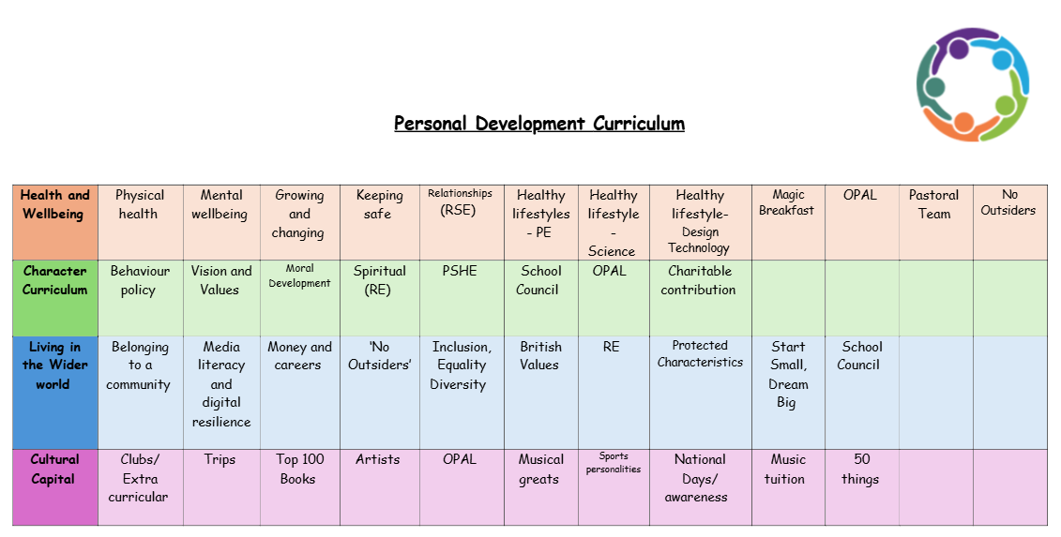
Behaviour
A relational and restorative behaviour system plays a significant role in supporting children's personal development by fostering an environment of trust, responsibility, empathy, and emotional growth.

1. Relational Aspect
Building Positive Relationships: A relational behaviour system focuses on creating strong, respectful relationships between students and teachers, as well as among peers. When children feel that their relationships with adults and classmates are positive, they are more likely to engage in learning and exhibit positive behaviours.
Emotional Support: Children develop a sense of belonging and security when they feel cared for and understood by adults. This emotional support is crucial for their confidence and well-being.
Social Skills Development: Through the relational model, children learn essential social skills such as communication, cooperation, and conflict resolution. They practice these skills in real-life situations, which are important for their social development.
2. Restorative Aspect
Accountability and Responsibility: Restorative practices encourage children to take responsibility for their actions. Instead of simply punishing misbehaviour, students are encouraged to reflect on their actions and understand the impact they have on others. This helps them develop a sense of accountability and moral reasoning.
Conflict Resolution: When conflicts arise, restorative practices focus on repairing harm and restoring relationships, rather than punishing the child. This teaches children how to address and resolve conflicts in constructive ways, which is a valuable life skill.
Empathy and Understanding: By engaging in restorative conversations, children learn to empathise with others, recognise their own emotions, and understand the feelings of others. This can lead to greater emotional intelligence and better interpersonal skills.
3. Personal Development Benefits
Self-Regulation: Both relational and restorative systems help children learn self-regulation by encouraging them to reflect on their behaviour and emotions. Through these practices, children become more aware of their actions and their consequences, helping them to make better choices in the future.
Growth Mindset: In a relational and restorative environment, mistakes are seen as opportunities for learning and growth, rather than failures. This fosters a growth mindset, where children feel encouraged to improve and develop resilience.
Increased Motivation: When children feel respected and understood, they are more likely to be motivated to do their best. Positive relationships and restorative practices help maintain a supportive learning environment where children feel safe to take risks and challenge themselves.
In essence, a relational and restorative behaviour system not only guides children to make better choices but also nurtures their emotional, social, and cognitive development.

