
Personal Development Curriculum
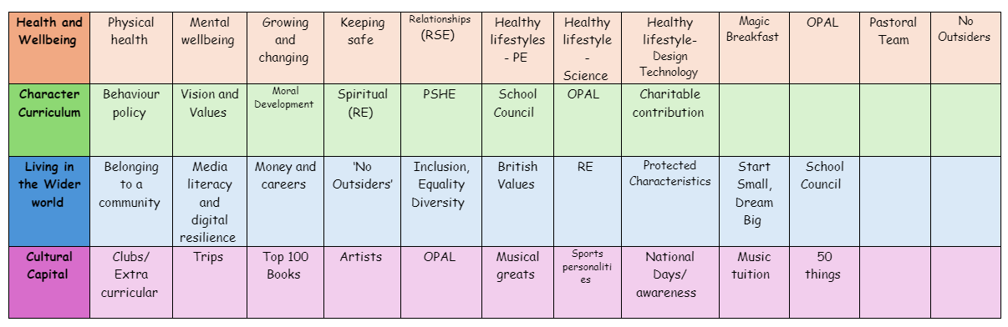
Doxey Academy
Pastoral Team

Our pastoral team at Doxey Academy is responsible for the well-being, personal development, and support of students.
Their role focuses on ensuring that children feel safe, happy, and supported both emotionally and socially, allowing them to thrive in their learning environment.

Their key responsibilities typically include:

1. Supporting Student Well-being
- Providing emotional support to students experiencing difficulties.
- Helping children build confidence and resilience.
- Monitoring mental health and behaviour concerns.
2. Safeguarding and Child Protection
- Ensuring that all children are safe from harm.
- Working closely with teachers and external agencies (e.g., social services) to protect vulnerable children.
- Following safeguarding policies and procedures.
3. Managing Behaviour and Attendance
- Supporting positive behaviour management strategies.
- Helping students with behavioural challenges develop better coping strategies.
- Addressing attendance and punctuality issues, working with families if necessary.
4. Building Relationships with Families
- Acting as a bridge between school and home to support students.
- Offering guidance and support to parents and carers.
- Encouraging parental involvement in school life.
5. Providing Pastoral Care Programs
- Running social skills groups, friendship clubs, or mentoring programs.
- Organizing well-being initiatives, such as mindfulness sessions.
- Supporting students through transitions, such as starting school or moving to secondary school.
6. Supporting Staff
- Helping teachers manage students with emotional or behavioural needs.
- Providing training on pastoral care and safeguarding.

