
Personal Development Curriculum
Magic Breakfast
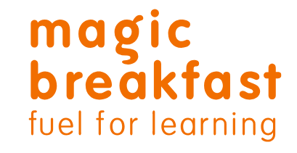
Magic Breakfast believe that no child should ever be too hungry to learn. They support schools in England and Scotland, and work with local authorities to feed children and help end child morning hunger for good.
Magic Breakfast work with 200,000 children and young people every school day.
They put the needs of children and young people at the heart of what they do. The schools they work with are in communities with high economic need. The engagement partners (staff member at Magic Breakfast) work closely with school staff and volunteers to make sure we’re providing barrier free breakfasts for all.
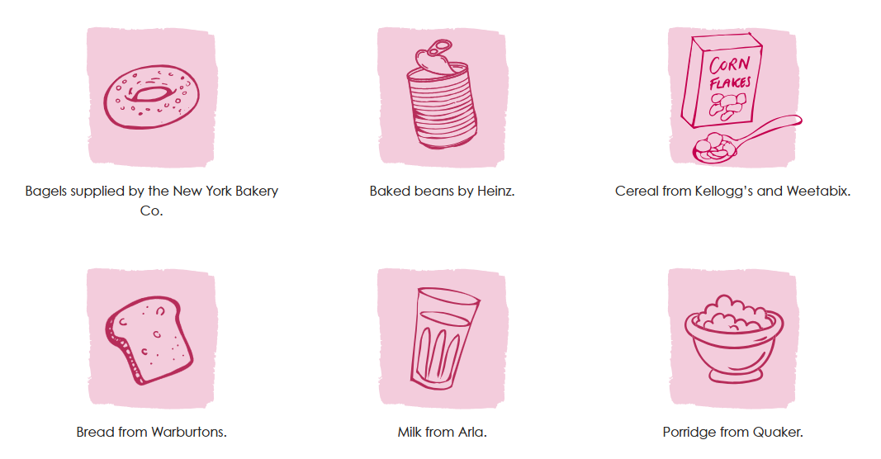
We continue to work with Magic Breakfast, and we offer bagels and toast every morning on the playground. Our nursery provisions offer a cereal breakfast as do our nurture provisions.
Our intention is to extend this provision to a sit down cereal breakfast for every child once a week.

