
Personal Development Curriculum
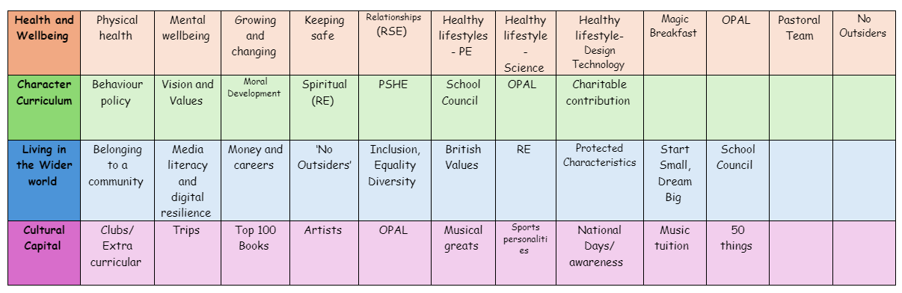
Healthy Lifestyle- Design and Technology
Teaching healthy lifestyles in Design and Technology (D&T) lessons is important because it helps children learn practical skills related to food, nutrition, and well-being while encouraging creativity and problem-solving.
1. Teaches Children About Nutrition and Cooking Skills
- Helps children understand the importance of a balanced diet and how to prepare healthy meals.
- Encourages them to make informed food choices and avoid unhealthy processed foods.
- Builds confidence in basic cooking skills, making them more likely to prepare healthy meals in the future.
2. Promotes Healthy Eating Habits
- Helps children explore how different foods affect their energy, growth, and concentration.
- Encourages trying new foods and developing a positive attitude toward healthy eating.
- Teaches portion control and meal planning, which helps prevent overconsumption of unhealthy foods.
3. Encourages Safe and Hygienic Food Preparation
- Teaches the importance of food safety, hygiene, and proper handling.
- Helps children understand how to store food correctly to prevent food poisoning.
- Encourages good habits like washing hands, cleaning surfaces, and using equipment safely.
4. Develops Practical Life Skills
- Encourages independence by teaching children how to plan, prepare, and cook meals.
- Helps them understand the link between design, health, and functionality in everyday life.
- Develops problem-solving skills by encouraging children to create healthier versions of recipes.
5. Supports Sustainable and Ethical Choices
- Encourages awareness of food waste, sustainability, and ethical food production.
- Helps children understand the impact of locally sourced, organic, and seasonal foods.
- Teaches them how to make eco-friendly choices when selecting ingredients and materials.
6. Links to Physical and Mental Well-being
- Shows how healthy food fuels the body for physical activity and brain function.
- Encourages children to think about ergonomic and safe kitchen design to support well-being.
- Helps children design products that support a healthy lifestyle, such as lunchboxes, sportswear, or fitness equipment.
How our D&T lessons promote Healthy Lifestyles
- Food technology projects, such as designing a healthy lunchbox or smoothie.
- Exploring kitchen safety and hygiene through hands-on activities.
- Sustainable product design, such as eco-friendly food packaging.
The following is the progression document in place to teach Healthy Lifestyles in dedicated Design & Technology lessons.
Year 1

I know that people need food and drink to stay alive.
I know that food and drink help me to grow, be active and stay healthy.
I know we need more of some foods than others.
I know that everyone should eat at least 5 portions of fruit and vegetables every day.
I can talk about foods I like and dislike and explain why.
I know that we eat different foods depending on the time of day, occasion and our lifestyle.
Year 2

I recognise the Eatwell Guide as a model which shows me how to eat healthily.
I can sort a selection of foods into the five Eatwell Guide food groups.
I can put together a simple, balanced meal (and include a drink) by choosing foods from the Eatwell Guide.
I know that different people eat or avoid certain foods for different reasons, and I can give some of these reasons, e.g. allergy, intolerance, religious belief.
Year 3

I know that what people around the world eat depends on reasons such as availability, preference, resources, time, culture and religion.
I know that what is eaten in different countries around the world can look different, but it usually includes combinations of foods from the same the Eatwell Guide groups.
I know that the word ‘diet’ means the amount and range of food eaten.
I know that a variety and balance of food and drink is needed to make a healthy diet.
I know that I need to have 6-8 drinks a day and more if it is hot or I am active.
Year 4

I understand that the different proportions of the Eatwell Guide reflect the proportions of foods which should be eaten from each group.
I can identify and classify ingredients in composite dishes according to the Eatwell Guide food groups.
I can use the Eatwell Guide model and messages to help me make healthy choices and plan healthy meals and menus for myself and others.
I know that different factors can affect our food choices and I can give some examples of these.
E.g. availability, cost, advertising, pressure.
Year 5

I know that different types of food provide different amounts of energy.
I know that energy provided by food and drink is measured in kilojoules (metric) and kilocalories (imperial).
I know that different amounts of food (portions) provide different amounts of energy.
I know that it is important to be aware of portion size when choosing food and drinks.
I know that different amounts of energy are needed by the body for different activities.
I know that different people need different amounts of energy.
I know that to be healthy, energy balance should be achieved (over a period of time).
Year 6

I understand that I need the nutrients - carbohydrate, protein, fat, vitamins and minerals - as well as fibre and water to be healthy.
I know that energy is provided by the nutrients carbohydrate, protein and fat.
I know that all food and drink provide nutrients.
I know that most foods and drinks contain a main nutrient but they will also contain other nutrients in smaller amounts.
I know that some foods provide fibre which is not digested but helps to keep the digestive system healthy.
I know that the body needs water to stay alive and that this can be found in drinks and in foods.
I know that the amount of energy and nutrients provided by food or drink depends on the amount (portion) eaten.
I can explain the basic function of each nutrient (carbohydrate, protein, fat, vitamins and minerals).
I can say the main nutrient/s provided by each Eatwell Guide food group.
I can identify and interpret the nutrition panel on food packaging and use it to help me make food choices.

