
Personal Development Curriculum
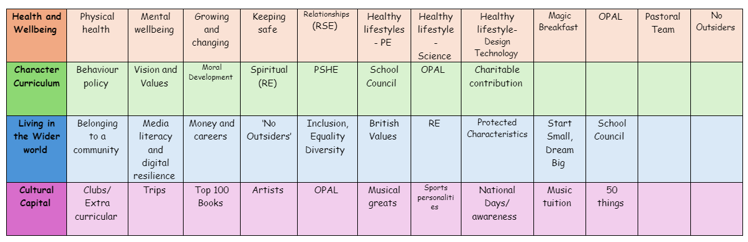
Healthy Lifestyle- Science
Teaching healthy lifestyles in science lessons is important because it helps children understand how their bodies work, the impact of their choices, and the science behind health and well-being.
1. Teaches How the Body Works
- Helps children understand the functions of different organs, like the heart, lungs, and digestive system.
- Explains how food, exercise, and sleep affect growth and energy levels.
- Encourages curiosity about how the human body stays healthy.
2. Promotes Good Nutrition and Healthy Eating
- Teaches the importance of balanced diets, including proteins, carbohydrates, fats, vitamins, and minerals.
- Helps children understand how different foods fuel the body and brain.
- Encourages healthy food choices by explaining the effects of sugar, fats, and processed foods.
3. Highlights the Importance of Exercise
- Explains how physical activity strengthens the heart, muscles, and bones.
- Helps children understand the science behind fitness, stamina, and energy levels.
- Links exercise to mental health benefits, like reducing stress and improving mood.
4. Encourages Good Hygiene and Disease Prevention
- Teaches children about germs, bacteria, and how illnesses spread.
- Encourages habits like washing hands, brushing teeth, and personal hygiene.
- Helps them understand the importance of vaccinations and immune system health.
5. Supports Mental Well-being and Brain Health
- Explains how sleep, hydration, and relaxation affect concentration and mood.
- Teaches children how their brains respond to stress, emotions, and learning.
- Encourages mindfulness and stress management as part of a healthy lifestyle.
6. Raises Awareness of Health Risks
- Teaches children about the dangers of smoking, alcohol, and unhealthy habits.
- Helps them understand how poor diet and lack of exercise can lead to diseases.
- Encourages them to make informed decisions about their health as they grow.
7. Builds Scientific Thinking and Problem-Solving Skills
- Encourages children to investigate, ask questions, and experiment (e.g., testing the effects of exercise on heart rate).
- Helps them analyse and understand cause-and-effect relationships (e.g., what happens if you don’t drink enough water?).
- Promotes critical thinking about health-related issues in society.
How our Science lessons teach Healthy Lifestyles
- Experiments on nutrition (e.g., testing foods for fats or sugars).
- Measuring pulse rates before and after exercise to understand fitness.
- Learning about germs and hygiene to explain disease prevention.
- Learning about the body’s systems, such as digestion, respiration, and circulation.
- Discussions on mental health and brain function linked to lifestyle choices.
The following is the progression document in place to teach healthy lifestyles in dedicated science lessons.
Year 1

Identify, name, draw and label the basic parts of the human body and say which part of the body is associated with each sense.
Year 2

Find out about and describe the basic needs of animals, including humans, for survival (water, food and air)
Describe the importance for humans of exercise, eating the right amounts of different types of food, and hygiene.
Year 3

Identify that animals, including humans, need the right types and amount of nutrition, and that they cannot make their own food; they get nutrition from what they eat
Identify that humans and some other animals have skeletons and muscles for support, protection and movement.
Year 4

Year 5

Year 6

Identify and name the main parts of the human circulatory system, and describe the functions of the heart, blood vessels and blood
Recognise the impact of diet, exercise, drugs and lifestyle on the way their body’s function
Describe the ways in which nutrients and water are transported within animals, including humans.

