
Personal Development Curriculum
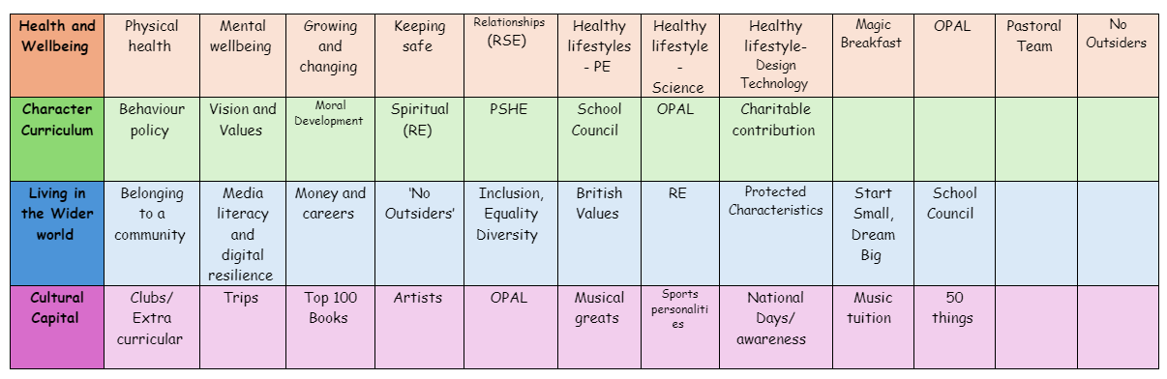
Healthy Lifestyle- PE
Teaching healthy lifestyles in PE lessons is important because it helps children develop positive habits, understand the benefits of physical activity, and take care of their overall well-being.
1. Encourages Lifelong Healthy Habits
- Helps children understand the importance of exercise, nutrition, and rest.
- Encourages them to stay active outside of school, reducing the risk of obesity and related health issues.
- Builds a strong foundation for making healthy choices throughout life.
2. Supports Physical Health and Growth
- Improves fitness, strength, and coordination through regular movement.
- Helps maintain a healthy weight and reduces the risk of diseases like diabetes and heart problems.
- Strengthens bones, muscles, and the immune system, helping children grow strong and resilient.
3. Boosts Mental Health and Well-being
- Physical activity releases endorphins, which help reduce stress, anxiety, and low mood.
- Teaches relaxation techniques (e.g., yoga, stretching) to support emotional well-being.
- Helps children manage emotions and improves focus, concentration, and self-esteem.
4. Improves Learning and Academic Performance
- Regular movement enhances brain function, improving memory and problem-solving skills.
- Active children are more likely to be engaged and ready to learn in other subjects.
- Encourages discipline, resilience, and teamwork, which are valuable in all areas of education.
5. Teaches the Importance of Nutrition and Hydration
- Helps children understand what foods fuel the body for energy and performance.
- Encourages healthy eating habits alongside physical activity.
- Teaches the importance of staying hydrated for overall well-being.
6. Promotes Teamwork and Social Skills
- Helps children develop communication and cooperation skills through team sports.
- Encourages fair play, respect, and perseverance, which are important in all aspects of life.
- Builds confidence in interacting with others and forming positive relationships.
7. Reduces Health Risks Later in Life
- Reduces the likelihood of developing health problems like obesity, heart disease, and diabetes.
- Teaches children how to look after their physical and mental health from an early age.
- Encourages a balanced approach to exercise, preventing an overly sedentary lifestyle.
How PE Lessons Can Promote Healthy Lifestyles
- Fun and engaging activities that encourage movement (e.g., dance, games, and sports).
- Education on nutrition, hydration, and rest alongside physical activity.
- Encouraging teamwork and social skills through cooperative games.
- Making fitness enjoyable so children develop a positive attitude toward exercise.
The following is the progression document in place to teach Healthy Lifestyles in dedicated PE lessons.
Year 1

Understand why being active is good for you.
Understand and describe changes to their heart rate when playing a game.
Understand how to play in a safe way and why being active and playing games is good for you.
Year 2

Begin to understand the important of preparing safely and carefully for exercise: warming up.
Begin to understand and describe changes to their heart rate when playing a game.
Year 3

Further understand the link between heart rate and breathing when exercising.
Begin to understand why you get hotter when you exercise and play games.
Describe how their bodies feel when exercising and understand the link between heart rate and breathing
when exercising
Year 4

Describe how your body feels when exercising, further understanding the link between heart rate and
breathing when exercising.
Devise suitable warm-up activities for the upcoming activities.
Year 5

Create short warm up routines that follow basic principle e.g. raise body temperature, mobilise joints and muscles.
Understand how the muscles work e.g. work by getting shorter, relax by getting longer.
Year 6

Explain how your body reacts and feels when taking part in different activities and undertaking different
roles.
Create short warm up routines that follow basic principles e.g. raise body temperature, mobilise joints and muscles.
Understand the importance of being physically fit and how physical activity can contribute to a healthy
lifestyle.
Develop physical fitness and be able to describe its importance in orienteering.

