
Personal Development Curriculum
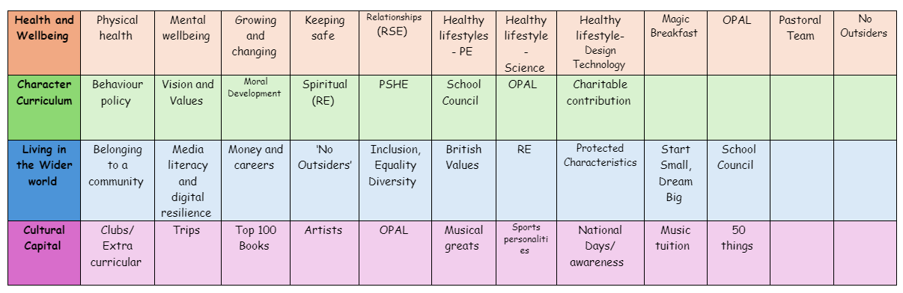
Relationships
Teaching about safe relationships, families, friendships, and respecting others is important because it helps children develop positive social skills, understand diversity, and build healthy relationships from an early age.
1. Encourages Healthy Friendships and Relationships
- Teaches children how to build positive and respectful friendships.
- Helps them understand the difference between healthy and unhealthy relationships.
- Encourages kindness, empathy, and inclusivity in their interactions with others.
2. Promotes Respect and Acceptance of Differences
- Helps children understand and respect different family structures, cultures, and beliefs.
- Encourages tolerance and inclusion, reducing discrimination and prejudice.
- Supports children in learning how to celebrate diversity in their communities.
3. Helps Prevent Bullying and Peer Pressure
- Teaches children how to recognize and respond to bullying or unkind behaviour.
- Encourages them to stand up for themselves and others in a respectful way.
- Helps them resist peer pressure and make their own safe choices.
4. Builds Emotional Well-being and Self-Esteem
- Encourages children to value themselves and others.
- Teaches them the importance of self-respect and confidence in relationships.
- Helps them recognize healthy boundaries and understand their right to feel safe.
5. Supports Understanding of Different Family Structures
- Helps children understand that families come in many forms (e.g., single-parent families, same-sex parents, blended families).
- Promotes acceptance and understanding, so all children feel included and valued.
- Reduces confusion or stigma about different family backgrounds.
6. Teaches Personal Boundaries and Consent
- Helps children understand what is appropriate and inappropriate behaviour in relationships.
- Reinforces the importance of asking for and giving consent, even in simple things like sharing toys or giving hugs.
- Encourages children to speak up if they feel uncomfortable or unsafe.
7. Prepares Children for Future Relationships
- Gives them a strong foundation for respectful relationships as they grow.
- Helps them understand trust, honesty, and good communication in friendships and family life.
- Reduces the risk of toxic friendships, manipulation, or unhealthy behaviours in later years.
How we teach these topics
- Circle time discussions on friendship, respect, and kindness.
- Storybooks and role-playing to explore different family types and relationships.
- Anti-bullying programs to promote kindness and inclusion.
- Lessons on consent and personal boundaries in age-appropriate ways.
- Encouraging open discussions so children feel safe to ask questions and share worries.
The following is the progression document in place to teach Relatioships in dedicated PSHE lessons.

Year 1

Families and friendships | Safe relationships | Respecting ourselves and others
• about people who care for them, e.g. parents, siblings, grandparents, relatives, friends, teachers  • the role these different people play in children’s lives and how they care for them  • what it means to be a family and how families are different, e.g. single parents, same-sex parents, etc.  • about the importance of telling someone — and how to tell them — if they are worried about something in their family | • about situations when someone’s body or feelings might be hurt and whom to go to for help  • about what it means to keep something private, including parts of the body that are private  • to identify different types of touch and how they make people feel (e.g. hugs, tickling, kisses and punches)  • how to respond if being touched makes them feel uncomfortable or unsafe  • when it is important to ask for permission to touch others  • how to ask for and give/not give permission | • what kind and unkind behaviour mean in and out school  • how kind and unkind behaviour can make people feel  • about what respect means  • about class rules, being polite to others, sharing and taking turns
Year 2

Families and friendships | Safe relationships | Respecting ourselves and others
• how to be a good friend, e.g. kindness, listening, honesty  • about different ways that people meet and make friends  • strategies for positive play with friends, e.g. joining in, including others, etc.  • about what causes arguments between friends  • how to positively resolve arguments between friends  • how to recognise, and ask for help, when they are feeling lonely or unhappy or to  help someone else | • how to recognise hurtful behaviour, including online  • what to do and whom to tell if they see or experience hurtful behaviour, including  online  • about what bullying is and different types of bullying  • how someone may feel if they are being bullied  • about the difference between happy surprises and secrets that make them feel  uncomfortable or worried, and how to get help  • how to resist pressure to do something that feels uncomfortable or unsafe  • how to ask for help if they feel unsafe or worried and what vocabulary to use | • about the things they have in common with their friends, classmates, and other  people  • how friends can have both similarities and differences  • how to play and work cooperatively in different groups and situations  • how to share their ideas and listen to others, take part in discussions, and give  reasons for their views
Year 3

Families and friendships | Safe relationships | Respecting ourselves and others
• to recognise and respect that there are different types of families, including single  parents, same-sex parents, step-parents, blended families, foster and adoptive  parents  • that being part of a family provides support, stability and love  • about the positive aspects of being part of a family, such as spending time together  and caring for each other  • about the different ways that people can care for each other e.g. giving  encouragement or support in times of difficulty  • to identify if/when something in a family might make someone upset or worried  • what to do and whom to tell if family relationships are making them feel unhappy or unsafe | • What is appropriate to share with friends, classmates, family and wider social groups  including online  • about what privacy and personal boundaries are, including online  • basic strategies to help keep themselves safe online e.g. passwords, using trusted  sites and adult supervision  • that bullying and hurtful behaviour is unacceptable in any situation  • about the effects and consequences of bullying for the people involved  • about bullying online, and the similarities and differences to face-to-face bullying  • what to do and whom to tell if they see or experience bullying or hurtful behaviour | • to recognise respectful behaviours e.g. helping or including others, being  responsible  • how to model respectful behaviour in different situations e.g. at home, at school,  online  • the importance of self-respect and their right to be treated respectfully by others  • what it means to treat others, and be treated, politely  • the ways in which people show respect and courtesy in different cultures and in  wider society
Year 4

Families and friendships | Safe relationships | Respecting ourselves and others
• about the features of positive healthy friendships such as mutual respect, trust and  sharing interests  • strategies to build positive friendships  • how to seek support with relationships if they feel lonely or excluded  • how to communicate respectfully with friends when using digital devices  • how knowing someone online differs from knowing someone face to face and that  there are risks in communicating with someone they don’t know  • what to do or whom to tell if they are worried about any contact online | • to differentiate between playful teasing, hurtful behaviour and bullying, including  online  • how to respond if they witness or experience hurtful behaviour or bullying, including  online  • recognise the difference between ‘playful dares’ and dares which put someone  under pressure, at risk, or make them feel uncomfortable  • how to manage pressures associated with dares  • when it is right to keep or break a confidence or share a secret  • how to recognise risks online such as harmful content or contact  • how people may behave differently online including pretending to be someone they  are not  • how to report concerns and seek help if worried or uncomfortable about someone’s  behaviour, including online | • to recognise differences between people such as gender, race, faith  • to recognise what they have in common with others e.g. shared values, likes and  dislikes, aspirations  • about the importance of respecting the differences and similarities between people  • a vocabulary to sensitively discuss difference and include everyone
Year 5

Families and friendships | Safe relationships | Respecting ourselves and others
• what makes a healthy friendship and how they make people feel included  • strategies to help someone feel included  • about peer influence and how it can make people feel or behave  • the impact of the need for peer approval in different situations, including online  • strategies to manage peer influence and the need for peer approval e.g. exit  strategies, assertive communication  • that it is common for friendships to experience challenges  • strategies to positively resolve disputes and reconcile differences in friendships  • that friendships can change over time and the benefits of having new and different  types of friends  • how to recognise if a friendship is making them feel unsafe, worried, or  uncomfortable  • when and how to seek support in relation to friendships | • to identify what physical touch is acceptable, unacceptable, wanted or unwanted in  different situations  • how to ask for, give and not give permission for physical contact  • how it feels in a person’s mind and body when they are uncomfortable  • that it is never someone’s fault if they have experienced unacceptable contact  • how to respond to unwanted or unacceptable physical contact  • that no one should ask them to keep a secret that makes them feel uncomfortable  or try to persuade them to keep a secret they are worried about  • whom to tell if they are concerned about unwanted physical contact | • to recognise that everyone should be treated equally  • why it is important to listen and respond respectfully to a wide range of people,  including those whose traditions, beliefs and lifestyle are different to their own  • what discrimination means and different types of discrimination e.g. racism, sexism,  homophobia  • to identify online bullying and discrimination of groups or individuals e.g. trolling and  Harassment  • the impact of discrimination on individuals, groups and wider society  • ways to safely challenge discrimination  • how to report discrimination online
Year 6

Families and friendships | Safe relationships | Respecting ourselves and others
• what it means to be attracted to someone and different kinds of loving relationships  • that people who love each other can be of any gender, ethnicity or faith  • the difference between gender identity and sexual orientation and everyone’s right  to be loved  • about the qualities of healthy relationships that help individuals flourish  • ways in which couples show their love and commitment to one another, including  those who are not married or who live apart  • what marriage and civil partnership mean e.g. a legal declaration of commitment  made by two adults  • that people have the right to choose whom they marry or whether to get married  • that to force anyone into marriage is illegal  • how and where to report forced marriage or ask for help if they are worried | • to compare the features of a healthy and unhealthy friendship  • about the shared responsibility if someone is put under pressure to do something  dangerous and something goes wrong  • strategies to respond to pressure from friends including online  • how to assess the risk of different online ‘challenges’ and ‘dares’  • how to recognise and respond to pressure from others to do something unsafe or  that makes them feel worried or uncomfortable  • how to get advice and report concerns about personal safety, including online  • what consent means and how to seek and give/not give permission in different  situations | • about the link between values and behaviour and how to be a positive role model  • how to discuss issues respectfully  • how to listen to and respect other points of view  • how to constructively challenge points of view they disagree with  • ways to participate effectively in discussions online and manage conflict or  disagreements

