
Personal Development Curriculum
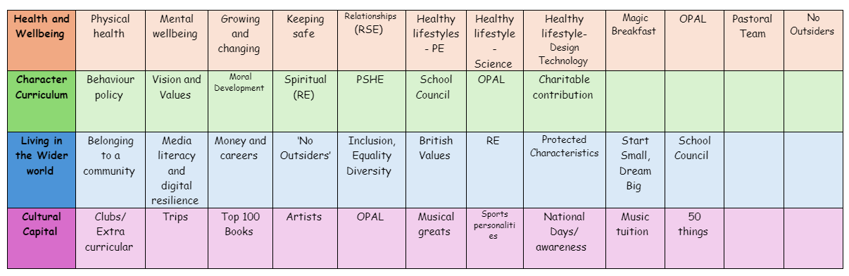
Keeping Safe
Teaching about keeping safe is essential because it helps children recognize dangers, make safe choices, and know how to seek help. It equips them with the knowledge and confidence to protect themselves in different situations.
1. Prevents Accidents and Injuries
- Helps children understand risks in everyday situations (e.g., road safety, fire safety, playground safety).
- Encourages safe behaviours, like crossing roads correctly or using equipment safely.
- Teaches basic first aid skills, such as what to do if someone is hurt.
2. Protects Against Stranger Danger and Online Risks
- Educates children about stranger awareness and how to react if approached by someone they don’t know.
- Helps them understand online safety, including protecting personal information and avoiding harmful content.
- Encourages responsible use of the internet, social media, and gaming platforms.
3. Teaches Personal Boundaries and Body Safety
- Helps children understand the difference between safe and unsafe touch.
- Teaches the importance of consent and saying "no" if something makes them uncomfortable.
- Encourages children to speak up if they feel unsafe or worried.
4. Builds Confidence in Seeking Help
- Teaches children who to go to for help, such as teachers, trusted adults, or emergency services.
- Helps them recognize unsafe situations and know how to respond.
- Encourages open discussions about feelings and concerns to prevent children from keeping worries to themselves.
5. Reduces the Risk of Exploitation and Abuse
- Educates children about grooming, bullying, and peer pressure in an age-appropriate way.
- Empowers them to recognize warning signs and protect themselves.
- Reinforces that they have the right to feel safe and that adults are there to help.
6. Prepares Children for Independence
- Helps them make safe choices as they grow and gain more independence.
- Encourages critical thinking in risky situations, such as when home alone or using public transport.
- Teaches basic emergency procedures, like calling 999 or knowing their address.
How we teach about Keeping Safe
- Road safety lessons (practicing crossing roads safely).
- Stranger danger role-play and discussions.
- Online safety workshops (how to use the internet responsibly).
- Lessons on personal boundaries and body safety (including "PANTS" rule by NSPCC).
- Fire drills and first aid activities to prepare for emergencies.
- Encouraging children to speak up through worry boxes, check-ins, and trusted adults.
The following is the progression document in place to teach Keeping Safe in dedicated PSHE lessons.
Year 1
• how rules can help to keep us safe
• why some things have age restrictions, e.g. TV and film, games, toys or play areas
• basic rules for keeping safe online
• whom to tell if they see something online that makes them feel unhappy, worried, or scared

Year 2
• how to recognise risk in everyday situations, e.g. road, water and rail safety, medicines
• how to help keep themselves safe in familiar and unfamiliar environments, such as in school, online and ‘out and about’
• to identify potential unsafe situations, who is responsible for keeping them safe in these situations, and steps they can take to avoid or remove themselves from danger
• how to help keep themselves safe at home in relation to electrical appliances, fire safety and medicines/household products
• about things that people can put into their body or onto their skin (e.g. medicines and creams) and how these can affect how people feel
• how to respond if there is an accident and someone is hurt
• about whose job it is to keep us safe and how to get help in an emergency, including how to dial 999 and what to say

Year 3
• how to identify typical hazards at home and in school
• how to predict, assess and manage risk in everyday situations e.g. crossing the road, running in the playground, in the kitchen
• about fire safety at home including the need for smoke alarms
• the importance of following safety rules from parents and other adults
• how to help keep themselves safe in the local environment or unfamiliar places, including road, rail, water and firework safety

Year 4
• the importance of taking medicines correctly and using household products safely
• to recognise what is meant by a ‘drug’
• that drugs common to everyday life (e.g. cigarettes, e-cigarettes/vaping, alcohol and medicines) can affect health and wellbeing
• to identify some of the effects related to different drugs and that all drugs, including medicines, may have side effects
• to identify some of the risks associated with drugs common to everyday life
• that for some people using drugs can become a habit which is difficult to break
• how to ask for help or advice

Year 5
• to identify when situations are becoming risky, unsafe or an emergency
• to identify occasions where they can help take responsibility for their own safety
• to differentiate between positive risk taking (e.g. trying a challenging new sport) and dangerous behaviour
• how to deal with common injuries using basic first aid techniques
• how to respond in an emergency, including when and how to contact different emergency services

Year 6
• how to protect personal information online
• to identify potential risks of personal information being misused
• strategies for dealing with requests for personal information or images of themselves
• to identify types of images that are appropriate to share with others and those which might not be appropriate
• that images or text can be quickly shared with others, even when only sent to one person, and what the impact of this might be
• what to do if they take, share or come across an image which may upset, hurt or embarrass them or others
• how to report the misuse of personal information or sharing of upsetting content/ images online
• about the different age rating systems for social media, T.V, films, games and online gaming
• why age restrictions are important and how they help people make safe decisions about what to watch, use or play
• about the risks and effects of different drugs
• about the laws relating to drugs common to everyday life and illegal drugs
• to recognise why people choose to use or not use drugs, including nicotine, alcohol and medicines as well as illegal drugs
• about the organisations where people can get help and support concerning drug use
• how to ask for help if they have concerns about drug use
• about mixed messages in the media relating to drug use and how they might influence opinions and decisions

