
Personal Development Curriculum
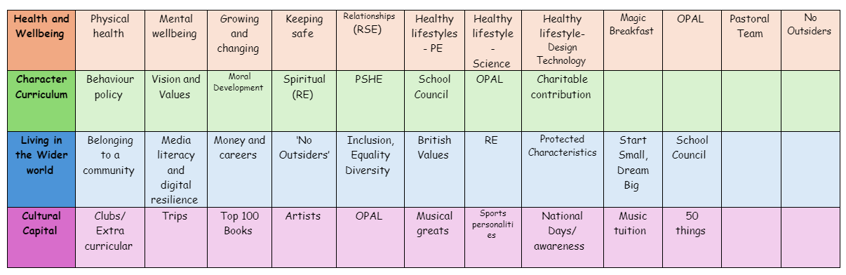
Mental Wellbeing
Teaching about mental health is essential because it helps children understand emotions, build resilience, and develop healthy coping strategies from an early age.
1. Encourages Emotional Well-being
- Helps children recognize and express their feelings in a healthy way.
- Teaches them how to handle emotions like stress, anger, and sadness.
- Reduces the risk of mental health issues developing later in life.
2. Builds Resilience and Coping Skills
- Equips children with tools to manage challenges, disappointments, and change.
- Encourages problem-solving and a positive mindset.
- Helps children develop self-confidence and self-esteem.
3. Reduces Stigma and Encourages Openness
- Normalizes talking about mental health, making children feel safe to ask for help.
- Teaches them that it’s okay to struggle and seek support.
- Helps create a supportive school environment where children look out for each other.
4. Supports Better Learning and Behaviour
- Emotionally healthy children focus better in class.
- Reduces anxiety and stress, leading to improved concentration and participation.
- Encourages positive relationships, reducing bullying and conflicts.
5. Promotes Healthy Life Habits
- Helps children develop habits like mindfulness, relaxation, and positive thinking.
- Encourages self-care, good sleep, and exercise, which support mental well-being.
- Prepares them for future challenges, including transitions to secondary school.
How we teach Mental Health
Well-being lessons on emotions, resilience, and self-care.
Emotional check-ins where children can share their feelings.
Encouraging kindness and empathy through group discussions and role-playing.
Providing access to support, such as a pastoral team
The following is the progression document in place to teach Mental Health in dedicated PSHE lessons.
Year 1
Year 2
• how to describe and share a range of feelings
• ways to feel good, calm down or change their mood e.g. playing outside, listening to music, spending time with others
• how to manage big feelings including those associated with change, loss and bereavement
• when and how to ask for help, and how to help others, with their feelings
Year 3
• that regular exercise such as walking or cycling has positive benefits for their mental and physical health
• about the things that affect feelings both positively and negatively
• strategies to identify and talk about their feelings
• about some of the different ways people express feelings e.g. words, actions, body language
• to recognise how feelings can change overtime and become more or less powerful

Year 4
Year 5
• healthy sleep strategies and how to maintain them
Year 6
• that mental health is just as important as physical health and that both need looking after
• to recognise that anyone can be affected by mental ill-health and that difficulties can be resolved with help and support
• how negative experiences such as being bullied or feeling lonely can affect mental wellbeing
• positive strategies for managing feelings
• that there are situations when someone may experience mixed or conflicting feelings
• how feelings can often be helpful, whilst recognising that they sometimes need to be overcome
• to recognise that if someone experiences feelings that are not so good (most or all of the time) – help and support is available
• identify where they and others can ask for help and support with mental wellbeing in and outside school
• the importance of asking for support from a trusted adult
• about the changes that may occur in life including death, and how these can cause conflicting feelings
• that changes can mean people experience feelings of loss or grief
• about the process of grieving and how grief can be expressed
• about strategies that can help someone cope with the feelings associated with change or loss
• to identify how to ask for help and support with loss, grief or other aspects of change
• how balancing time online with other activities helps to maintain their health and wellbeing
• strategies to manage time spent online and foster positive habits e.g. switching phone off at night
• what to do and whom to tell if they are frightened or worried about something they have seen online

