
Personal Development Curriculum
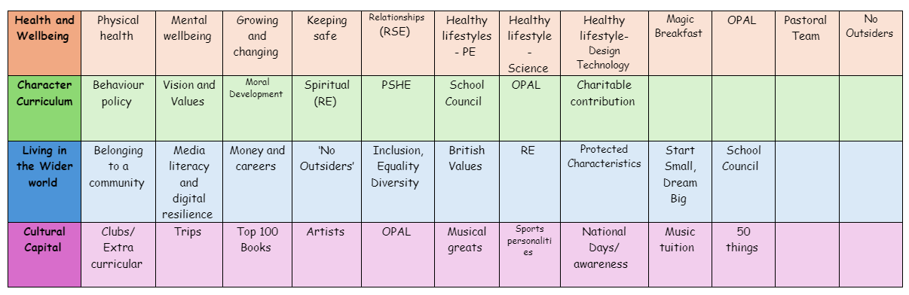
Physical Health
Physical health is crucial because it directly affects a child’s growth, learning, and overall well-being.

1. Supports Healthy Growth and Development
- Encourages strong bones and muscles.
- Helps maintain a healthy weight and reduces the risk of obesity.
- Strengthens the immune system, reducing illness and absences.

2. Boosts Learning and Concentration
- Physical activity improves blood flow to the brain, enhancing focus and memory.
- Active children tend to be more engaged in lessons and learn better.
- Exercise releases endorphins, which boost mood and reduce stress, leading to better behaviour in class.

3. Encourages Good Mental Health
- Reduces anxiety, stress, and depression.
- Helps children build confidence and self-esteem through sports and play.
- Provides an outlet for releasing pent-up energy, helping with emotional regulation.

4. Develops Social Skills and Teamwork
- Playing sports and games teaches cooperation, patience, and teamwork.
- Helps children make friends and develop a sense of belonging.
- Encourages problem-solving and resilience when facing challenges.

5. Builds Healthy Habits for Life
- Children who are active in primary school are more likely to stay active as they grow up.
- Helps establish lifelong habits like healthy eating, regular exercise, and good hygiene.
- Teaches the importance of rest and sleep for a healthy body and mind.

How we promote Physical Health
Weekly PE lessons to keep children active.
Active playtimes with games and sports equipment.
Healthy eating programs with nutritious school meals.
Encouraging walking or cycling to school.
Mindfulness and relaxation exercises to support mental well-being.
The following is the progression document in place to teach Physical Health in dedicated PSHE lessons.
Year 1

• what it means to be healthy and why it is important
• ways to take care of themselves on a daily basis
• about basic hygiene routines, e.g. hand washing
• about healthy and unhealthy foods, including sugar intake
• about physical activity and how it keeps people healthy
• about different types of play, including balancing indoor, outdoor and screen-based play
• about people who can help them to stay healthy, such as parents, doctors, nurses, dentists, lunch supervisors
• how to keep safe in the sun
Year 2

• about routines and habits for maintaining good physical and mental health
• why sleep and rest are important for growing and keeping healthy
• that medicines, including vaccinations and immunisations, can help people stay healthy and manage allergies
• the importance of, and routines for, brushing teeth and visiting the dentist
• about food and drink that affect dental health
Year 3

• about the choices that people make in daily life that could affect their health
• to identify healthy and unhealthy choices (e.g. in relation to food, exercise, sleep)
• what can help people to make healthy choices and what might negatively influence them
• about habits and that sometimes they can be maintained, changed or stopped
• the positive and negative effects of habits, such as regular exercise or eating too much sugar, on a healthy lifestyle
• what is meant by a healthy, balanced diet including what foods should be eaten regularly or just occasionally
• that regular exercise such as walking or cycling has positive benefits for their mental and physical health
Year 4

• to identify a wide range of factors that maintain a balanced, healthy lifestyle, physically and mentally
• what good physical health means and how to recognise early signs of physical illness
• that common illnesses can be quickly and easily treated with the right care e.g. visiting the doctor when necessary
• how to maintain oral hygiene and dental health, including how to brush and floss correctly
• the importance of regular visits to the dentist and the effects of different foods, drinks and substances on dental health

Year 5

• how sleep contributes to a healthy lifestyle
• healthy sleep strategies and how to maintain them
• about the benefits of being outdoors and in the sun for physical and mental health
• how to manage risk in relation to sun exposure, including skin damage and heat stroke
• how medicines can contribute to health and how allergies can be managed
• that some diseases can be prevented by vaccinations and immunisations
• that bacteria and viruses can affect health
• how they can prevent the spread of bacteria and viruses with everyday hygiene routines
• to recognise the shared responsibility of keeping a clean environment
Year 6

• how balancing time online with other activities helps to maintain their health and wellbeing

